Python NIQ FAQs

1. Please solve the below Binary Gap Question.  
     
   A binary gap within a positive integer N is any maximal sequence of consecutive zeros that is surrounded by ones at  
   both ends in the binary representation of N.  
     
   For example,  
   The number 9 has binary representation 1001 and contains a binary gap of length 2.  
   The number 529 has binary representation 1000010001 and contains two binary gaps: one of length 4 and one of length 3.  
   The number 20 has binary representation 10100 and contains one binary gap of length 1.  
   The number 15 has binary representation 1111 and has no binary gaps.  
   The number 32 has binary representation 100000 and has no binary gaps.

def solution(N):

binary_string = str(bin(N))[2:]  
  
 gap = max_gap = 0  
 for char in binary_string:  
 if char == "0":  
 gap += 1  
 else:  
 max_gap = max(gap, max_gap)  
 gap = 0  
  
 return max_gap

1. What is the difference between lists and tuples in Python?
   * + **List:** Ordered, mutable, allows duplicate elements. Defined using square brackets [].
     + **Tuple:** Ordered, immutable, allows duplicate elements. Defined using parentheses ()

# List example

my_list = [1, 2, 3]

print("Original list:", my_list)

my_list[0] = 10  # Modifying the first element

print("Modified list:", my_list)

# Tuple example

my_tuple = (1, 2, 3)

print("Original tuple:", my_tuple)

# my_tuple[0] = 10  # This will raise an error because tuples are immutable

1. How is memory managed in Python?

Memory management in Python involves a private heap containing all Python objects and data structures. The management of this private heap is ensured internally by the Python memory manager. Python also has an inbuilt garbage collector, which recycles all the unused memory to make it available for heap space

er

1. What is __init__?

 __init__ is a special method in Python classes, known as a constructor. It is automatically called when a new instance of the class is created, allowing the class to initialize the attributes of the object

1. What are decorators in Python?

Decorators are a way to modify or extend the behavior of functions or methods without changing their actual code. They are usually defined with the @decorator_name

decorator that creates logs the execution of a function

def my_decorator(func):  
 def wrapper():  
 print("Something is happening before the function is called.")  
 func()  
 print("Something is happening after the function is called.")  
 return wrapper  
  
@my_decorator  
def say_hello():  
 print("Hello!")   
  
say_hello()

1. What are Python modules and packages?

* **Module:** A module is a single Python file that can be imported and used in other Python scripts. It can contain functions, classes, and variables.
* **Package:** A package is a collection of modules organized in directories that include a special __init__.py file

1. What are generators in Python?

Generators are a type of iterable, like lists or tuples. Unlike lists, they do not store their contents in memory. Instead, they generate values on the fly using the yield keyword

def count_up_to(max):

    count = 1

    while count <= max:

        yield count

        count += 1

# Using the generator

for num in count_up_to(5):

    print(num)sss

1. What is TensorFlow and how is it used in Python?

TensorFlow is an open-source library for machine learning and artificial intelligence. It is used for a wide range of tasks, including neural network training and inference, and it provides a flexible platform for building machine learning models

1. What is Pandas and how is it used?

Pandas is a powerful data manipulation and analysis library for Python. It provides data structures like DataFrame and Series, which are used for handling and analyzing data efficiently

1. Explain the use of NumPy in Python.

NumPy is a library for numerical computing in Python. It provides support for arrays, matrices, and many mathematical functions to operate on these data structures

**Example 1: Creating and Manipulating Arrays**

import numpy as np

# Creating a 1D array

array_1d = np.array([1, 2, 3, 4, 5])

print("1D Array:", array_1d)

# Creating a 2D array

array_2d = np.array([[1, 2, 3], [4, 5, 6]])

print("2D Array:\n", array_2d)

# Reshaping an array

reshaped_array = array_1d.reshape((5, 1))

print("Reshaped Array:\n", reshaped_array)

**Example 2: Basic Array Operations**

# Creating two arrays

a = np.array([1, 2, 3])

b = np.array([4, 5, 6])

# Element-wise addition

sum_array = a + b

print("Sum:", sum_array)

# Element-wise multiplication

product_array = a * b

print("Product:", product_array)

# Dot product

dot_product = np.dot(a, b)

print("Dot Product:", dot_product)

**Example 3: Statistical Operations**

# Creating an array

data = np.array([1, 2, 3, 4, 5, 6, 7, 8, 9, 10])

# Calculating mean

mean = np.mean(data)

print("Mean:", mean)

# Calculating standard deviation

std_dev = np.std(data)

print("Standard Deviation:", std_dev)

# Calculating sum

total_sum = np.sum(data)

print("Sum:", total_sum)

**Example 4: Using NumPy for Linear Algebra**

# Creating a 2x2 matrix

matrix = np.array([[1, 2], [3, 4]])

# Calculating the determinant

determinant = np.linalg.det(matrix)

print("Determinant:", determinant)

# Calculating the inverse

inverse = np.linalg.inv(matrix)

print("Inverse:\n", inverse)

These examples demonstrate some of the basic functionalities of NumPy

1. **List Comprehension**

In Python, **list comprehension** is a concise way to create lists. It allows you to generate a new list by applying an expression to each item in an iterable (like a list, tuple, or range), optionally filtering elements with a condition.

**🔹 Basic Syntax:**

[expression for item in iterable if condition]

* **expression**: The value to store in the new list.
* **item**: The variable representing each element in the iterable.
* **iterable**: A sequence (like a list or range).
* **condition** (optional): A filter that selects which items to include.

**✅ Example 1: Square of numbers from 0 to 9**

squares = [x**2 for x in range(10)]

print(squares)

**Output:**

[0, 1, 4, 9, 16, 25, 36, 49, 64, 81]

**✅ Example 2: Get even numbers from a list**

numbers = [1, 2, 3, 4, 5, 6]

evens = [x for x in numbers if x % 2 == 0]

print(evens)

**Output:**

[2, 4, 6]

**✅ Example 3: Convert words to uppercase**

words = ["hello", "world"]

upper_words = [word.upper() for word in words]

print(upper_words)

**Output:**

['HELLO', 'WORLD']

Would you like to try writing one yourself? I can help you build it!

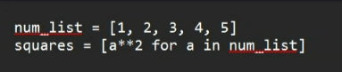

1. How to merge List and Tuple

Yes, in Python, you can **combine lists and tuples**, but it's important to understand how they behave differently:

* A **list** is mutable (you can change its contents).
* A **tuple** is immutable (you cannot change its contents once created).

**🔹 Ways to Combine Lists and Tuples**

**✅ 1. Add a tuple to a list**

my_list = [1, 2, 3]

my_tuple = (4, 5)

combined = my_list + list(my_tuple)

print(combined)

**Output:**

[1, 2, 3, 4, 5]

**✅ 2. Add a list to a tuple**

my_tuple = (1, 2, 3)

my_list = [4, 5]

combined = my_tuple + tuple(my_list)

print(combined)

**Output:**

(1, 2, 3, 4, 5)

**✅ 3. Nested combination**

You can also nest a tuple inside a list or vice versa:

nested = [1, 2, (3, 4)]

print(nested)

**Output:**

[1, 2, (3, 4)]

Would you like to see how to iterate over a mixed list of tuples and lists?

1. **What is the use of lambda functions?**

* Lambda functions in Python are small, anonymous functions defined using the lambda keyword. They are often used for short, simple operations that are not complex enough to require a full function definition. Lambda functions can have any number of arguments but only one expression. The expression is evaluated and returned.
* **Use of Lambda Functions**
* Lambda functions are commonly used in situations where a small function is required for a short period, such as in functional programming constructs like map(), filter(), and reduce(). They are also used to create small, throwaway functions that are not reused elsewhere in the code.

# List of numbers

numbers = [1, 2, 3, 4, 5]

# Using lambda function with map() to square each number

squared_numbers = list(map(lambda x: x ** 2, numbers))

print(squared_numbers)

1. What are Arbitrary Arguments?

Arbitrary Arguments are often shortened to *args in Python documentations.

If you do not know how many arguments that will be passed into your function, add a * before the parameter name in the function definition. This way the function will receive a tuple of arguments, and can access the items accordingly.

Using *args for Arbitrary Positional Arguments : The *args syntax allows a function to accept any number of positional arguments, which are then accessible as a tuple.

def sum_all(*args):

return sum(args)

# Example usage

result = sum_all(1, 2, 3, 4, 5)

print(result) # Output: 15

Using **kwargs for Arbitrary Keyword Arguments : **kwargs  allows a function to accept any number of keyword arguments, which are then accessible as a dictionary

def print_details(**kwargs):

for key, value in kwargs.items():

print(f"{key}: {value}")

# Example usage

print_details(name="John", age=30, city="New York")

1. Merge two dictionaries

Yes, in Python, you can merge two dictionaries in several ways depending on your Python version.

✅ Method 1: Using | Operator (Python 3.9+)

dict1 = {'a': 1, 'b': 2}

dict2 = {'b': 3, 'c': 4}

merged = dict1 | dict2

print(merged)

Output:

{'a': 1, 'b': 3, 'c': 4}

If keys overlap, the second dictionary's values overwrite the first.

✅ Method 2: Using update() Method

dict1 = {'a': 1, 'b': 2}

dict2 = {'b': 3, 'c': 4}

dict1.update(dict2)

print(dict1)

Output:

{'a': 1, 'b': 3, 'c': 4}

This modifies dict1 in place.

✅ Method 3: Using Dictionary Unpacking (Python 3.5+)

dict1 = {'a': 1, 'b': 2}

dict2 = {'b': 3, 'c': 4}

merged = {**dict1, **dict2}

print(merged)

Output:

{'a': 1, 'b': 3, 'c': 4}

Would you like to merge dictionaries with nested structures or lists as values too? I can show that as well!

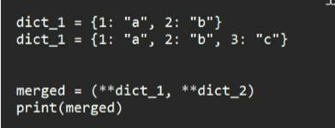

1. What is the purpose of generators in Python?

Functions that create iterators, producing values one at a time instead of storing the entire sequence in memory.

Efficient for iterating over large datasets or situations where generating all elements upfront is unnecessary.

Use yield keyword to return each element sequentially.

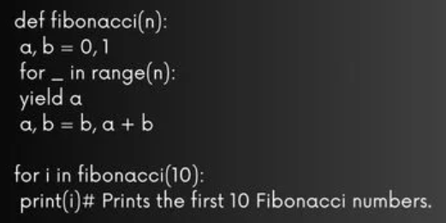

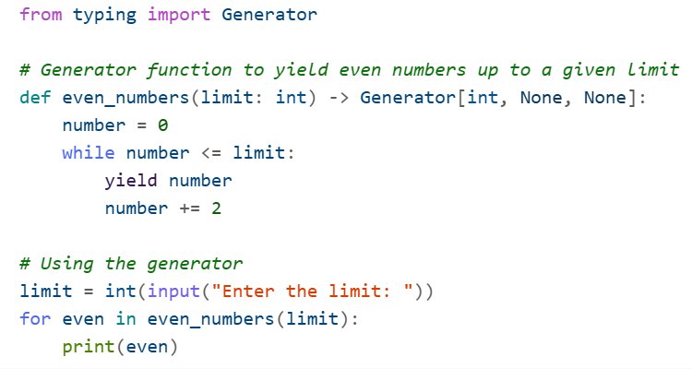

Generators in Python are used to create iterators in a simple and efficient way. They allow you to iterate through a sequence of values without storing them all in memory at once. This is particularly useful for working with large datasets or streams of data.

**Purpose of Generators**

1. **Memory Efficiency:** Generators produce values one at a time and only when needed, which saves memory.
2. **Lazy Evaluation:** Values are generated on-the-fly, allowing for efficient computation and iteration.
3. **Readable Code:** Generators can simplify code that involves complex iteration logic.

**Example**

**Here's an example of a generator function that yields even numbers up to a given limit:**

def even_numbers(limit):

number = 0

while number <= limit:

yield number

number += 2

# Using the generator

limit = int(input("Enter the limit: "))

for even in even_numbers(limit):

print(even)

**Explanation:**

* **Generator Function:** The even_numbers function uses the yield keyword to generate even numbers up to the specified limit.
* **Using the Generator:** The for loop iterates through the values produced by the generator, printing each even number.

Benefits:

* **Memory Efficiency:** Only one value is stored in memory at a time.
* **Lazy Evaluation:** Values are computed as needed, which can improve performance.
* **Simplified Code:** Generators can make iteration logic more straightforward and readable.

1. Please write a Python program using Pandas to find the second highest salary in each department from a given set of employee data:

import pandas as pd

# Sample data

data = {

'Employee': ['John', 'Alice', 'Bob', 'Eve', 'Charlie'],

'Department': ['HR', 'IT', 'IT', 'HR', 'Finance'],

'Salary': [50000, 60000, 70000, 55000, 65000]

}

# Create DataFrame

df = pd.DataFrame(data)

# Group by Department and get the 2nd highest salary in each department

second_highest_salaries = df.groupby('Department')['Salary'].apply(lambda x: x.nlargest(2).iloc[-1])

print(second_highest_salaries)

1. Write a program to find the second highest salary in each department without using Pandas.

# Sample data

employees = [

{'Employee': 'John', 'Department': 'HR', 'Salary': 50000},

{'Employee': 'Alice', 'Department': 'IT', 'Salary': 60000},

{'Employee': 'Bob', 'Department': 'IT', 'Salary': 70000},

{'Employee': 'Eve', 'Department': 'HR', 'Salary': 55000},

{'Employee': 'Charlie', 'Department': 'Finance', 'Salary': 65000}

]

# Group salaries by department

department_salaries = {}

for emp in employees:

dept = emp['Department']

salary = emp['Salary']

if dept not in department_salaries:

department_salaries[dept] = []

department_salaries[dept].append(salary)

# Find the second highest salary in each department

second_highest_salaries = {}

for dept, salaries in department_salaries.items():

if len(salaries) > 1:

sorted_salaries = sorted(salaries, reverse=True)

second_highest_salaries[dept] = sorted_salaries[1]

else:

second_highest_salaries[dept] = None # Not enough employees to determine the second highest salary

# Print the results

for dept, salary in second_highest_salaries.items():

print(f"The second highest salary in the {dept} department is: {salary}")

1. What is the difference between @classmethod, @staticmethod, and instance methods in Python?

1. Instance Method operates on an instance of the class and has access to instance attributes and takes self as the first parameter.

Example:

def method(self):

2. Class Method directly operates on the class itself and not on instance, it takes cls as the first parameter. and defined with[@classmethod.](https://www.geeksforgeeks.org/classmethod-in-python/)

Example: @classmethod def method(cls):

3. Static Method does not operate on an instance or the class and takes no self or cls as an argument and is defined with [@staticmethod.](https://www.geeksforgeeks.org/python-staticmethod/)

Example: @staticmethod def method(): align it and dont bolod anything and not bullet points

[**Top Python Interview Questions and Answers (2025) - InterviewBit**](https://www.interviewbit.com/python-interview-questions/)

1. difference between git commit vs git pull
2. how to acheive polymorphism in python
3. types of polymorphism in python
4. Anonymous function in python

In Python, an anonymous function is created using the lambda keyword. These functions are also known as **lambda functions**. They are typically used for short, simple operations and can be defined without a name.

**Syntax**

The syntax for a lambda function is:

lambda arguments: expression

**Example**

Here's a basic example of a lambda function that adds two numbers:

add = lambda x, y: x + y

print(add(5, 3)) # Output: 8

**Usage in Higher-Order Functions**

Lambda functions are often used with higher-order functions like map(), filter(), and reduce().

**Example with map()**

numbers = [1, 2, 3, 4]

squared = list(map(lambda x: x ** 2, numbers))

print(squared) # Output: [1, 4, 9, 16]

**Example with filter()**

numbers = [1, 2, 3, 4, 5, 6]

even_numbers = list(filter(lambda x: x % 2 == 0, numbers))

print(even_numbers) # Output: [2, 4, 6]

**Example with reduce()**

from functools import reduce

numbers = [1, 2, 3, 4]

sum_numbers = reduce(lambda x, y: x + y, numbers)

print(sum_numbers) # Output: 10

**Key Characteristics**

1. **Anonymous**: Lambda functions do not have a name.
2. **Single Expression**: They are limited to a single expression.
3. **Inline**: They are often used inline with other functions.

**When to Use Lambda Functions**

* **Simple Operations**: When you need a simple function for a short operation.
* **Higher-Order Functions**: When using functions like map(), filter(), and reduce().

Would you like more examples or details on lambda functions in Python?

1. Diff between method and function in python

In Python, both methods and functions are used to perform actions, but they have some key differences:

**Functions**

* **Definition**: A function is a block of code that performs a specific task and can be called independently.
* **Syntax**: Defined using the def keyword.
* **Usage**: Functions can be called anywhere in the code and can be passed around as arguments.
* **Example**:

def greet(name):

return f"Hello, {name}!"

print(greet("Alice"))

**Methods**

* **Definition**: A method is a function that is associated with an object. Methods are defined within a class and are called on instances of that class.
* **Syntax**: Defined using the def keyword within a class.
* **Usage**: Methods are called on objects and can access and modify the object's attributes.
* **Example**:

class Person:

def __init__(self, name):

self.name = name

def greet(self):

return f"Hello, {self.name}!"

person = Person("Alice")

print(person.greet())

**Key Differences**

* **Association**: Functions are standalone, while methods are associated with class instances.
* **Calling**: Functions are called by their name, while methods are called on objects.
* **Access**: Methods can access and modify the attributes of the object they belong to, while functions do not have this capability.

Would you like to dive deeper into any of these concepts or see more examples? 😊

1. how python is interpreted
2. **What is decorator**

In Python, a decorator is a function that modifies the behavior of another function or method. Decorators are often used to add functionality to functions or methods without changing their code. They are commonly used for logging, access control, memoization, and more.

**How Decorators Work**

Decorators wrap a function, modifying its behavior. They take a function as an argument, add some functionality, and return a new function.

**Example**

Here's a simple example of a decorator that logs the execution of a function:

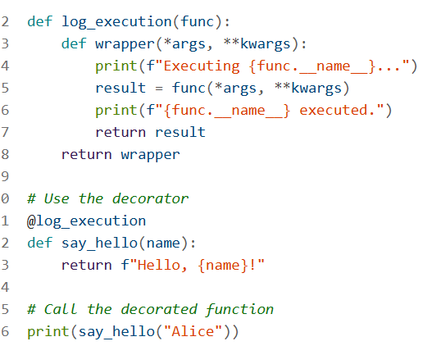

Executing say_hello...

say_hello executed.

Hello, Alice!

**Explanation:**

* **Decorator Function**: log_execution is a decorator that logs when a function starts and finishes execution.
* **Wrapper Function**: The wrapper function adds the logging functionality and calls the original function.
* **Using the Decorator**: The @log_execution syntax is used to apply the decorator to the say_hello function.

**Benefits of Decorators:**

* **Code Reusability**: Decorators allow you to reuse common functionality across multiple functions.
* **Separation of Concerns**: They help separate the core logic of functions from auxiliary tasks like logging or access control.
* **Readability**: Decorators can make code more readable by clearly indicating modifications to function behavior.

1. **What is difference between list and Dictionaries**

Lists and dictionaries are both used to store collections of items in Python, but they have distinct differences in terms of structure, usage, and functionality.

**Lists**

* **Ordered**: Elements in a list maintain their order.
* **Indexed**: Elements are accessed by their position (index) in the list.
* **Mutable**: You can change, add, or remove elements after the list is created.
* **Syntax**: Defined using square brackets [].

**Example**:

my_list = [1, 2, 3, 4]

print(my_list[2]) # Output: 3

my_list.append(5)

print(my_list) # Output: [1, 2, 3, 4, 5]

**Dictionaries**

* **Unordered**: Elements in a dictionary do not maintain any specific order.
* **Key-Value Pairs**: Elements are accessed by keys, which are unique identifiers.
* **Mutable**: You can change, add, or remove key-value pairs after the dictionary is created.
* **Syntax**: Defined using curly braces {}.
* **Example**:

my_dict = {'a': 1, 'b': 2, 'c': 3}

print(my_dict['b']) # Output: 2

my_dict['d'] = 4

print(my_dict) # Output: {'a': 1, 'b': 2, 'c': 3, 'd': 4}

**Key Differences**

* **Access Method**: Lists use indices to access elements, while dictionaries use keys.
* **Order**: Lists maintain the order of elements, whereas dictionaries do not.
* **Structure**: Lists are simple sequences of elements, while dictionaries are collections of key-value pairs.

1. **How memory management in python**

Memory management in Python involves several mechanisms to efficiently allocate, use, and free memory. Here are the key components:

Python's memory management involves several components, including the **Python memory manager**, **garbage collector**, and **heap memory**.

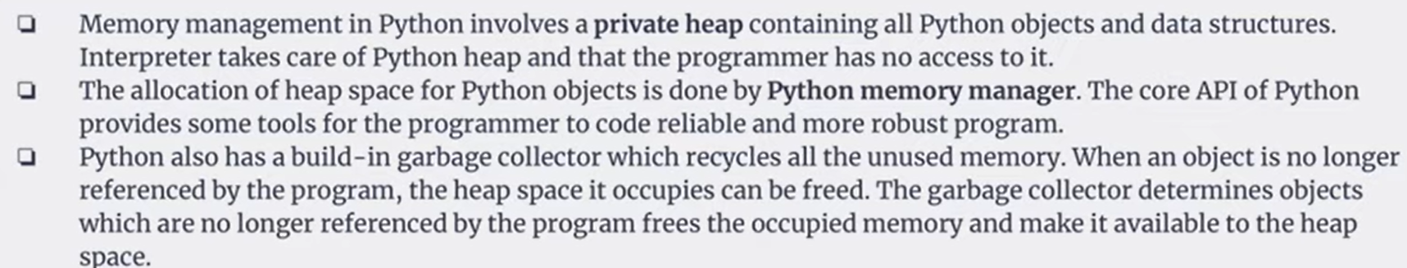

**Memory Management in Python**

1. **Python Memory Manager**:
   * Python has a built-in memory manager that handles the allocation and deallocation of memory for Python objects.
   * It uses different strategies for different types of objects, such as small objects and large objects.
2. **Garbage Collection**:
   * Python uses a garbage collector to reclaim memory by removing objects that are no longer in use.
   * It primarily uses reference counting and a cyclic garbage collector to handle circular references.
3. **Heap Memory**:
   * Python objects and data structures are stored in a private heap.
   * The Python memory manager manages this heap and ensures efficient memory allocation.

**Setting Up Heap Memory**

While you don't typically need to manually manage heap memory in Python, you can influence memory usage and optimize performance:

1. **Using gc Module**:
   * You can interact with the garbage collector using the gc module.
   * Example:

import gc

gc.collect() # Manually trigger garbage collection

1. **Memory Profiling**:
   * Use memory profiling tools to monitor and optimize memory usage.
   * Example tools: memory_profiler, objgraph.
2. **Custom Allocators**:
   * For advanced use cases, you can implement custom memory allocators using C extensions.

**1. Automatic Memory Management**

Python uses automatic memory management, meaning it handles memory allocation and deallocation without requiring explicit intervention from the programmer.

**2. Reference Counting**

Python uses reference counting to keep track of the number of references to each object. When an object's reference count drops to zero, the memory occupied by the object is deallocated.

**Example:**

a = [1, 2, 3]

b = a # Reference count for the list [1, 2, 3] is now 2

del a # Reference count drops to 1

del b # Reference count drops to 0, memory is deallocated

**3. Garbage Collection**

Python has a built-in garbage collector that handles cyclic references (objects referencing each other in a cycle). The garbage collector periodically checks for and cleans up these cycles to free memory.

**Example:**

import gc

# Enable garbage collection

gc.enable()

# Create cyclic references

a = []

b = [a]

a.append(b)

# Manually trigger garbage collection

gc.collect()

**4. Memory Pools**

Python uses memory pools to manage small objects. This helps reduce fragmentation and improve performance. The memory allocator groups objects of similar sizes into pools.

**5. Virtual Memory**

Python relies on the underlying operating system's virtual memory management to handle large objects and overall memory allocation.

**Summary**

**Automatic Memory Management**: Python handles memory allocation and deallocation automatically.

**Reference Counting**: Keeps track of the number of references to objects and deallocates memory when the count drops to zero.

**Garbage Collection**: Cleans up cyclic references to free memory.

**Memory Pools**: Manages small objects efficiently to reduce fragmentation.

**Virtual Memory:** Utilizes the operating system's virtual memory management.

1. What is difference between Generator and iterator

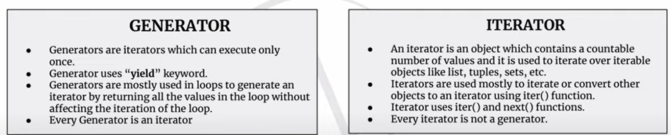

In Python, **generators** and **iterators** are both used to iterate over a sequence of values, but they have some key differences.

**Iterators**

**Definition**: An iterator is an object that implements the iterator protocol, which consists of the methods __iter__() and __next__().

**Usage**: You can create an iterator from any iterable (like lists, tuples, etc.) using the iter() function.

**Example**:

my_list = [1, 2, 3, 4]

iterator = iter(my_list)

print(next(iterator)) # Output: 1

print(next(iterator)) # Output: 2

print(next(iterator)) # Output: 3

print(next(iterator)) # Output: 4

**Generators**

**Definition**: A generator is a special type of iterator that is defined using a function with the yield keyword.

**Usage**: Generators allow you to declare a function that behaves like an iterator. They are more memory-efficient because they generate values on the fly and do not store the entire sequence in memory.

**Example**:

def my_generator():

yield 1

yield 2

yield 3

yield 4

gen = my_generator()

print(next(gen)) # Output: 1

print(next(gen)) # Output: 2

print(next(gen)) # Output: 3

print(next(gen)) # Output: 4

**Key Differences**

1. **Syntax**:
   * Iterators are created using classes and implementing __iter__() and __next__() methods.
   * Generators are created using functions and the yield keyword.
2. **Memory Efficiency**:
   * Iterators can be less memory-efficient as they may require storing the entire sequence.
   * Generators are more memory-efficient as they generate values on the fly.
3. **Ease of Use**:
   * Generators are often easier to implement and read compared to iterators.

Would you like to see more examples or have any specific questions about generators or iterators?

1. **What are the most popular Python packages widely used**
2. **NumPy**: Essential for numerical computing, providing support for large, multi-dimensional arrays and matrices, along with a collection of mathematical functions to operate on these arrays
3. **Pandas**: A powerful data manipulation and analysis library, particularly useful for working with structured data (e.g., data frames)
4. **Matplotlib**: A plotting library for creating static, animated, and interactive visualizations in Python
5. **Scikit-learn**: A machine learning library that provides simple and efficient tools for data mining and data analysis
6. **TensorFlow**: An open-source library for machine learning and artificial intelligence, developed by Google
7. **Keras**: A high-level neural networks API, written in Python and capable of running on top of TensorFlow
8. **Flask**: A lightweight WSGI web application framework, ideal for building small to medium-sized web applications
9. **Django**: A high-level Python web framework that encourages rapid development and clean, pragmatic design
10. **Requests**: A simple, yet elegant HTTP library for making HTTP requests in Python
11. **BeautifulSoup**: A library for parsing HTML and XML documents, useful for web
12. **What is Module and package in python.**

In Python, **modules** and **packages** are used to organize and structure code, making it easier to manage and reuse.

**Modules**

* **Definition**: A module is a single file (with a .py extension) that contains Python code. It can define functions, classes, and variables, and can also include runnable code.
* **Usage**: Modules help in organizing code into manageable sections.
* **Example**:

# my_module.py

def greet(name):

return f"Hello, {name}!"

# main.py

import my_module

print(my_module.greet("Alice")) # Output: Hello, Alice!

**Packages**

* **Definition**: A package is a collection of modules organized in a directory hierarchy. A package must contain a special file named __init__.py to be recognized as a package.
* **Usage**: Packages allow for a structured organization of modules, making it easier to manage large codebases.
* **Example**:

my_package/

├── __init__.py

├── module1.py

└── module2.py

# my_package/module1.py

def func1():

return "Function 1"

# my_package/module2.py

def func2():

return "Function 2"

# main.py

from my_package import module1, module2

print(module1.func1()) # Output: Function 1

print(module2.func2()) # Output: Function 2

**Key Differences**

1. **Structure**:
   * A module is a single file.
   * A package is a directory containing multiple modules.
2. **Usage**:
   * Modules are used to encapsulate code into a single file.
   * Packages are used to organize related modules into a directory structure.

To import a package in Python, you need to follow a few simple steps. Here's a guide on how to do it:

**Step-by-Step Guide to Importing a Package**

**Create the Package Structure**:

Ensure your package directory contains an __init__.py file. This file can be empty or contain initialization code for the package.

Example structure:

my_package/

├── __init__.py

├── module1.py

└── module2.py

**Write Code in Modules**:

Add functions, classes, or variables in your module files.

Example:

# my_package/module1.py

def func1():

return "Function 1 from module1"

# my_package/module2.py

def func2():

return "Function 2 from module2"

**Import the Package in Your Script**:

Use the import statement to import the package or specific modules from the package.

Example:

# main.py

from my_package import module1, module2

print(module1.func1()) # Output: Function 1 from module1

print(module2.func2()) # Output: Function 2 from module2

**Importing Specific Functions or Classes**

You can also import specific functions or classes from a module within a package:

# main.py

from my_package.module1 import func1

from my_package.module2 import func2

print(func1()) # Output: Function 1 from module1

print(func2()) # Output: Function 2 from module2

**Importing All Functions or Classes**

If you want to import everything from a module, you can use the * operator:

# main.py

from my_package.module1 import *

from my_package.module2 import *

print(func1()) # Output: Function 1 from module1

print(func2()) # Output: Function 2 from module2

**Using Aliases**

You can also use aliases to shorten the module names:

# main.py

import my_package.module1 as m1

import my_package.module2 as m2

print(m1.func1()) # Output: Function 1 from module1

print(m2.func2()) # Output: Function 2 from module2

Would you like more examples or details on any specific aspect of importing packages in Python?

1. What are inbuild data types in python and explain mutable and immutable datatype.

Python has several built-in data types that can be broadly categorized into mutable and immutable types.

**Built-in Data Types**

1. **Numeric Types**:
   * **int**: Integer values (e.g., 5, -3)
   * **float**: Floating-point values (e.g., 3.14, -2.0)
   * **complex**: Complex numbers (e.g., 1+2j)
2. **Sequence Types**:
   * **str**: String values (e.g., "hello", "world")
   * **list**: List values (e.g., [1, 2, 3], ["a", "b", "c"])
   * **tuple**: Tuple values (e.g., (1, 2, 3), ("a", "b", "c"))
3. **Mapping Type**:
   * **dict**: Dictionary values (e.g., {"key1": "value1", "key2": "value2"})
4. **Set Types**:
   * **set**: Set values (e.g., {1, 2, 3}, {"a", "b", "c"})
   * **frozenset**: Immutable set values (e.g., frozenset({1, 2, 3}))
5. **Boolean Type**:
   * **bool**: Boolean values (True, False)
6. **None Type**:
   * **None**: Represents the absence of a value or a null value.

**Mutable vs Immutable Data Types**

**Mutable Data Types**:

* **Definition**: Mutable data types are those that can be changed after they are created. You can modify their content without creating a new object.
* **Examples**:
  + **list**: You can add, remove, or change elements. python my_list = [1, 2, 3] my_list[0] = 10 # Change element my_list.append(4) # Add element print(my_list) # Output: [10, 2, 3, 4]
  + **dict**: You can add, remove, or change key-value pairs. python my_dict = {"key1": "value1", "key2": "value2"} my_dict["key1"] = "new_value" # Change value my_dict["key3"] = "value3" # Add key-value pair print(my_dict) # Output: {'key1': 'new_value', 'key2': 'value2', 'key3': 'value3'}
  + **set**: You can add or remove elements. python my_set = {1, 2, 3} my_set.add(4) # Add element my_set.remove(2) # Remove element print(my_set) # Output: {1, 3, 4}

**Immutable Data Types**:

* **Definition**: Immutable data types are those that cannot be changed after they are created. Any modification results in the creation of a new object.
* **Examples**:
  + **str**: You cannot change the characters in a string. python

my_str = "hello"

new_str = my_str.replace("h", "j")

# Creates a new string

print(new_str) # Output: "jello"

* + **tuple**: You cannot change the elements in a tuple. python

my_tuple = (1, 2, 3) # Any attempt to change elements will result in an error

# my_tuple[0] = 10 # This will raise a TypeError

* + **frozenset**: You cannot add or remove elements from a frozenset. python

my_frozenset = frozenset({1, 2, 3})

# Any attempt to change elements will result in an error

# my_frozenset.add(4) # This will raise an AttributeError

**Summary**

* **Mutable**: list, dict, set
* **Immutable**: int, float, complex, str, tuple, frozenset, bool, None

Would you like more examples or details on any specific data type?

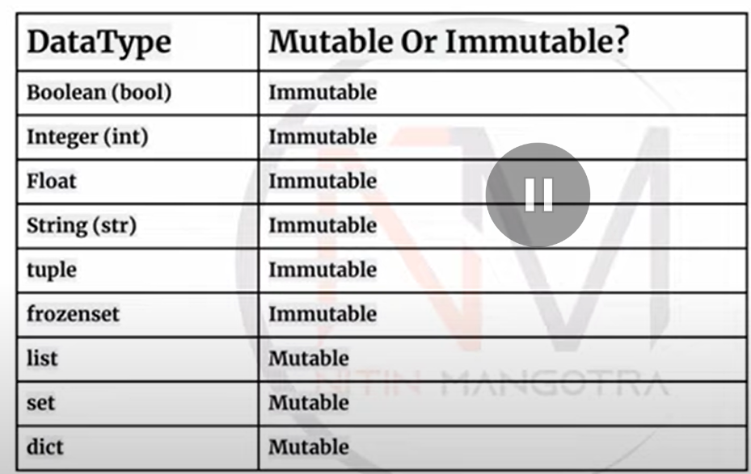

1. **What is the Ternary Operator in python.**

The ternary operator in Python is a way to condense an if-else statement into a single line. It's also known as the conditional expression.

**Syntax**

The syntax for the ternary operator is:

value_if_true if condition else value_if_false

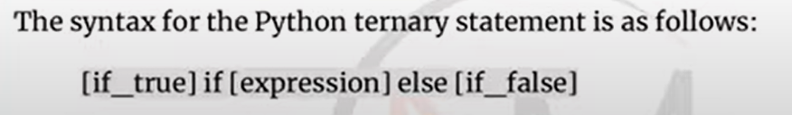

**Example**

Let's say you want to assign a value based on a condition:

# Traditional if-else statement

age = 18

if age >= 18:

status = "Adult"

else:

status = "Minor"

print(status) # Output: Adult

# Using the ternary operator

status = "Adult" if age >= 18 else "Minor"

print(status) # Output: Adult

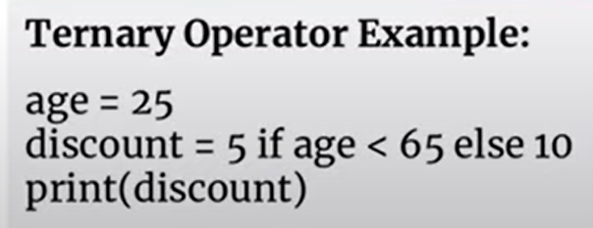

**Another Example**

Here's another example to demonstrate the ternary operator with a different condition:

# Traditional if-else statement

number = 10

if number % 2 == 0:

result = "Even"

else:

result = "Odd"

print(result) # Output: Even

# Using the ternary operator

result = "Even" if number % 2 == 0 else "Odd"

print(result) # Output: Even

**Benefits**

* **Concise**: It allows you to write shorter and more readable code.
* **Inline**: It can be used directly within expressions, making it useful for quick assignments.

Would you like more examples or details on how to use the ternary operator in Python?

1. What is inheritance in python

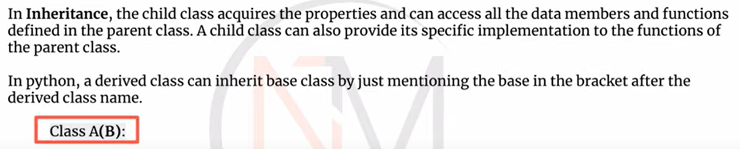

Inheritance is a fundamental concept in object-oriented programming (OOP) that allows a class to inherit attributes and methods from another class. This promotes code reuse and establishes a hierarchical relationship between classes.

**Types of Inheritance in Python**

1. **Single Inheritance**: A class inherits from one superclass.
2. **Multiple Inheritance**: A class inherits from more than one superclass.
3. **Multilevel Inheritance**: A class inherits from a superclass, which in turn inherits from another superclass.
4. **Hierarchical Inheritance**: Multiple classes inherit from the same superclass.
5. **Hybrid Inheritance**: A combination of two or more types of inheritance.

**Example of Single Inheritance**

# Base class

class Animal:

def __init__(self, name):

self.name = name

def speak(self):

pass

# Derived class

class Dog(Animal):

def speak(self):

return f"{self.name} says Woof!"

# Usage

dog = Dog("Buddy")

print(dog.speak()) # Output: Buddy says Woof!

**Example of Multiple Inheritance**

# Base classes

class Animal:

def __init__(self, name):

self.name = name

class Mammal:

def has_fur(self):

return True

# Derived class

class Dog(Animal, Mammal):

def speak(self):

return f"{self.name} says Woof!"

# Usage

dog = Dog("Buddy")

print(dog.speak()) # Output: Buddy says Woof!

print(dog.has_fur()) # Output: True

**Example of Multilevel Inheritance**

# Base class

class Animal:

def __init__(self, name):

self.name = name

# Intermediate class

class Mammal(Animal):

def has_fur(self):

return True

# Derived class

class Dog(Mammal):

def speak(self):

return f"{self.name} says Woof!"

# Usage

dog = Dog("Buddy")

print(dog.speak()) # Output: Buddy says Woof!

print(dog.has_fur()) # Output: True

**Example of Hierarchical Inheritance**

# Base class

class Animal:

def __init__(self, name):

self.name = name

# Derived classes

class Dog(Animal):

def speak(self):

return f"{self.name} says Woof!"

class Cat(Animal):

def speak(self):

return f"{self.name} says Meow!"

# Usage

dog = Dog("Buddy")

cat = Cat("Whiskers")

print(dog.speak()) # Output: Buddy says Woof!

print(cat.speak()) # Output: Whiskers says Meow!

**Example of Hybrid Inheritance**

# Base classes

class Animal:

def __init__(self, name):

self.name = name

class Mammal:

def has_fur(self):

return True

# Intermediate class

class Dog(Animal, Mammal):

def speak(self):

return f"{self.name} says Woof!"

# Derived class

class Labrador(Dog):

def fetch(self):

return f"{self.name} fetches the ball!"

# Usage

lab = Labrador("Buddy")

print(lab.speak()) # Output: Buddy says Woof!

print(lab.has_fur()) # Output: True

print(lab.fetch()) # Output: Buddy fetches the ball!

**Summary**

Inheritance allows you to create a new class that reuses, extends, or modifies the behavior of another class. This helps in reducing redundancy and improving code organization.

Would you like more details on any specific type of inheritance or further examples?

1. What is difference between local variable and global variable in python.

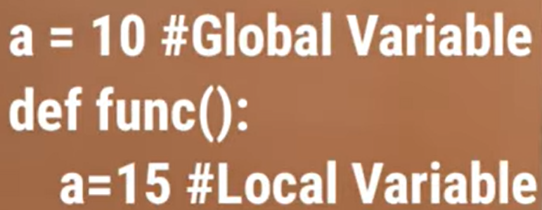

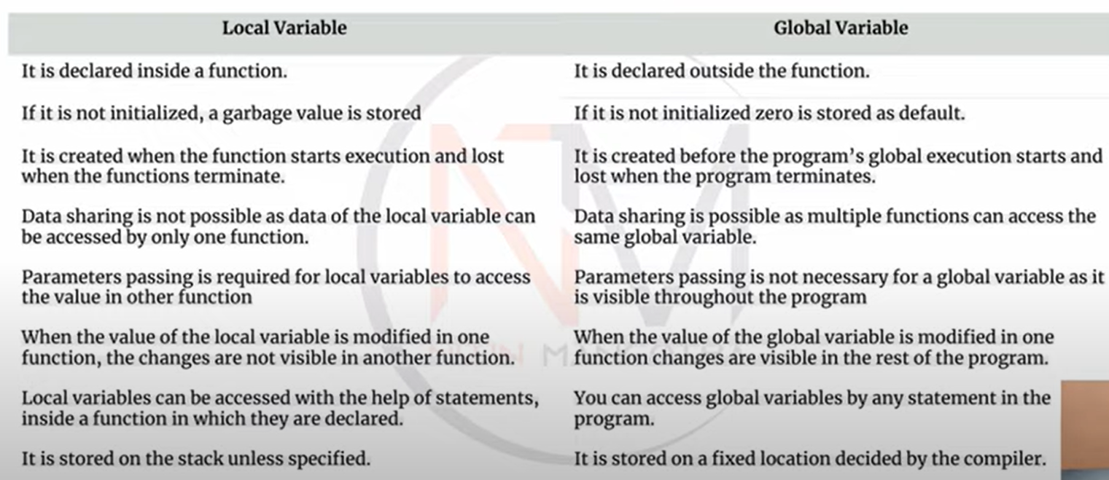

In Python, the main difference between local and global variables lies in their scope and lifetime.

**Local Variables**

* **Definition**: A local variable is defined within a function and is only accessible within that function.
* **Scope**: Limited to the function where it is defined.
* **Lifetime**: Exists only during the execution of the function.
* **Example**:

def my_function():

local_var = "I am local"

print(local_var)

my_function() # Output: I am local

# print(local_var) # This will raise a NameError because local_var is not accessible outside the function

**Global Variables**

* **Definition**: A global variable is defined outside of any function and is accessible throughout the entire program.
* **Scope**: Available throughout the entire program, including inside functions (unless shadowed by a local variable with the same name).
* **Lifetime**: Exists for the duration of the program.
* **Example**:

global_var = "I am global"

def my_function():

print(global_var)

my_function() # Output: I am global

print(global_var) # Output: I am global

**Modifying Global Variables Inside a Function**

To modify a global variable inside a function, you need to use the global keyword:

global_var = "I am global"

def my_function():

global global_var

global_var = "I have been modified"

print(global_var)

my_function() # Output: I have been modified

print(global_var) # Output: I have been modified

**Key Differences**

1. **Scope**:
   * Local variables are only accessible within the function they are defined in.
   * Global variables are accessible throughout the entire program.
2. **Lifetime**:
   * Local variables exist only during the execution of the function.
   * Global variables exist for the duration of the program.
3. **Usage**:
   * Local variables are used for temporary storage within a function.
   * Global variables are used for values that need to be accessed by multiple functions or throughout the program.

Would you like more examples or details on how to use local and global variables in Python?

1. What is the access specifier in python.

In Python, **access specifiers** (also known as **access modifiers**) control the visibility and accessibility of class attributes and methods. Python does not have explicit access specifiers like public, private, and protected found in some other programming languages. Instead, it uses naming conventions to indicate the intended level of access.

**Types of Access Specifiers in Python**

1. **Public**:

**Definition**: Attributes and methods that are accessible from anywhere.

**Naming Convention**: No special prefix.

**Example**:

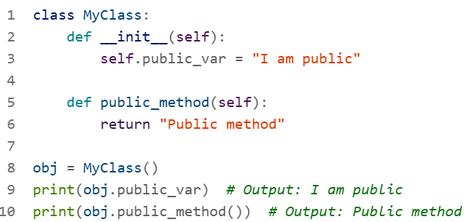

1. **Protected**:
   * **Definition**: Attributes and methods that are intended to be accessible within the class and its subclasses.
   * **Naming Convention**: Single underscore prefix (_).
   * **Example**:

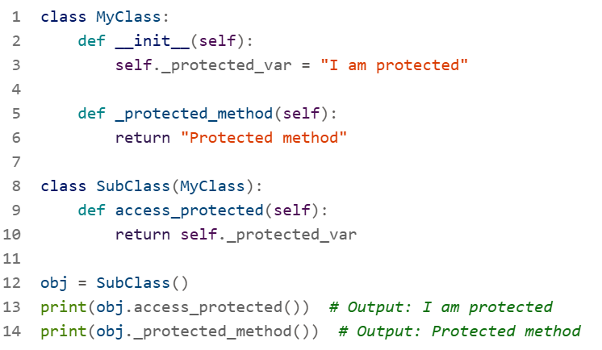

1. **Private**:
   * **Definition**: Attributes and methods that are intended to be accessible only within the class.
   * **Naming Convention**: Double underscore prefix (__).
   * **Example**:

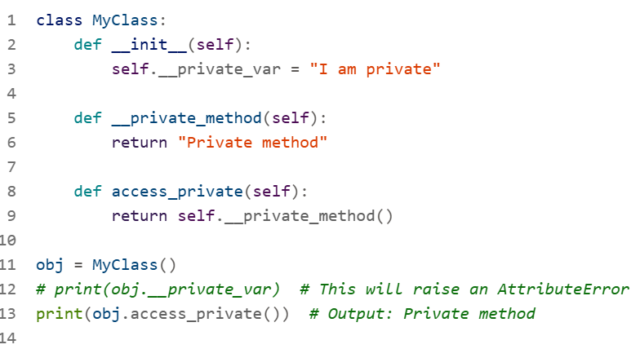

**Summary**

* **Public**: Accessible from anywhere. No special prefix.
* **Protected**: Intended for internal use within the class and its subclasses. Single underscore prefix (_).
* **Private**: Intended for internal use within the class only. Double underscore prefix (__).

Would you like more examples or details on how to use access specifiers in Python?

1. What is break, continue and pass statement in python

In Python, the break, continue, and pass statements are used to control the flow of loops and other control structures. Here's a detailed explanation of each:

**Break Statement**

**Purpose**: The break statement is used to exit a loop prematurely when a certain condition is met.

**Usage**: It can be used in for and while loops.

**Example**:

for i in range(10):

if i == 5:

break

print(i)

# Output: 0 1 2 3 4

**Continue Statement**

**Purpose**: The continue statement is used to skip the current iteration of a loop and proceed to the next iteration.

**Usage**: It can be used in for and while loops.

**Example**:

for i in range(10):

if i % 2 == 0:

continue

print(i)

# Output: 1 3 5 7 9

**Pass Statement**

**Purpose**: The pass statement is a null operation; it is used as a placeholder in situations where a statement is syntactically required but you don't want to execute any code.

**Usage**: It can be used in loops, functions, classes, or conditional statements.

**Example**:

for i in range(10):

if i % 2 == 0:

pass # Placeholder for future code

else:

print(i)

# Output: 1 3 5 7 9

**Summary**

* **break**: Exits the loop when a condition is met.
* **continue**: Skips the current iteration and continues with the next iteration.
* **pass**: Does nothing; acts as a placeholder.

Would you like more examples or details on how to use these statements in Python?

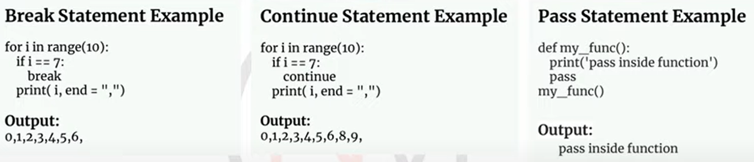

1. What is self keyword in python.

The self keyword in Python is used within class methods to refer to the instance of the class. It allows you to access attributes and methods of the class in Python's object-oriented programming.

**Key Points**

1. **Instance Reference**: self refers to the instance of the class from which the method is called.
2. **First Parameter**: It is always the first parameter in instance methods.
3. **Access Attributes and Methods**: It allows you to access and modify instance attributes and call other methods within the class.

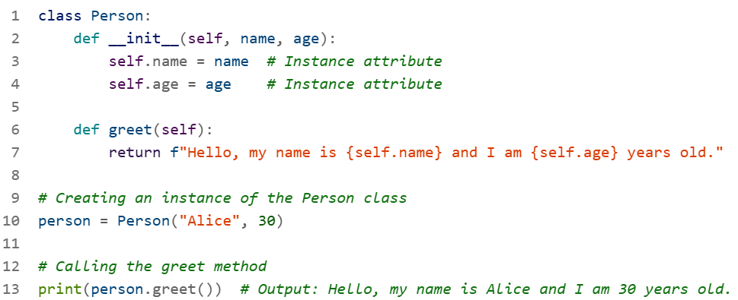

**Explanation**

**__init__ Method**: The __init__ method is the constructor method that initializes the instance attributes name and age. The self parameter refers to the instance being created.

**greet Method**: The greet method uses self to access the instance attributes name and age.

**Why Use self?**

**Consistency**: It ensures that each instance of the class maintains its own set of attributes.

**Clarity**: It makes the code more readable and understandable by clearly indicating that the attributes and methods belong to the instance.

1. what is pickling and unpckling in python

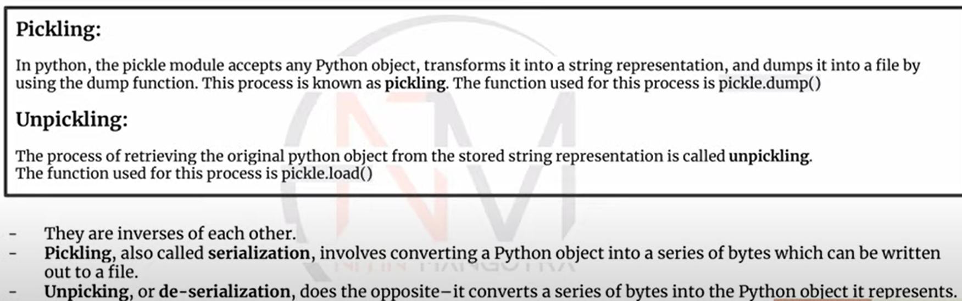

Pickling and unpickling are processes used in Python for serializing and deserializing objects, respectively. These processes are handled by the pickle module.

**Pickling**

**Definition**: Pickling is the process of converting a Python object into a byte stream, which can then be stored in a file or transmitted over a network.

**Usage**: It is used to save the state of an object so that it can be reloaded later.

**Example**:

import pickle

# Example object

data = {"name": "Alice", "age": 30, "city": "New York"}

# Pickling the object

with open("data.pkl", "wb") as file:

pickle.dump(data, file)

**Unpickling**

**Definition**: Unpickling is the process of converting a byte stream back into a Python object.

**Usage**: It is used to restore the state of an object that was previously pickled.

**Example**:

import pickle

# Unpickling the object

with open("data.pkl", "rb") as file:

data = pickle.load(file)

print(data) # Output: {'name': 'Alice', 'age': 30, 'city': 'New York'}

**Key Points**

**Serialization**: Pickling is a form of serialization, which means converting an object into a format that can be easily stored or transmitted.

**Deserialization**: Unpickling is a form of deserialization, which means converting the serialized format back into an object.

**Security**: Be cautious when unpickling data from untrusted sources, as it can execute arbitrary code and pose security risks.

**Summary**

* **Pickling**: Convert an object to a byte stream using pickle.dump().
* **Unpickling**: Convert a byte stream back to an object using pickle.load().

Would you like more examples or details on how to use pickling and unpickling in Python?

1. What are the functions of list, tuple, set and dict in python

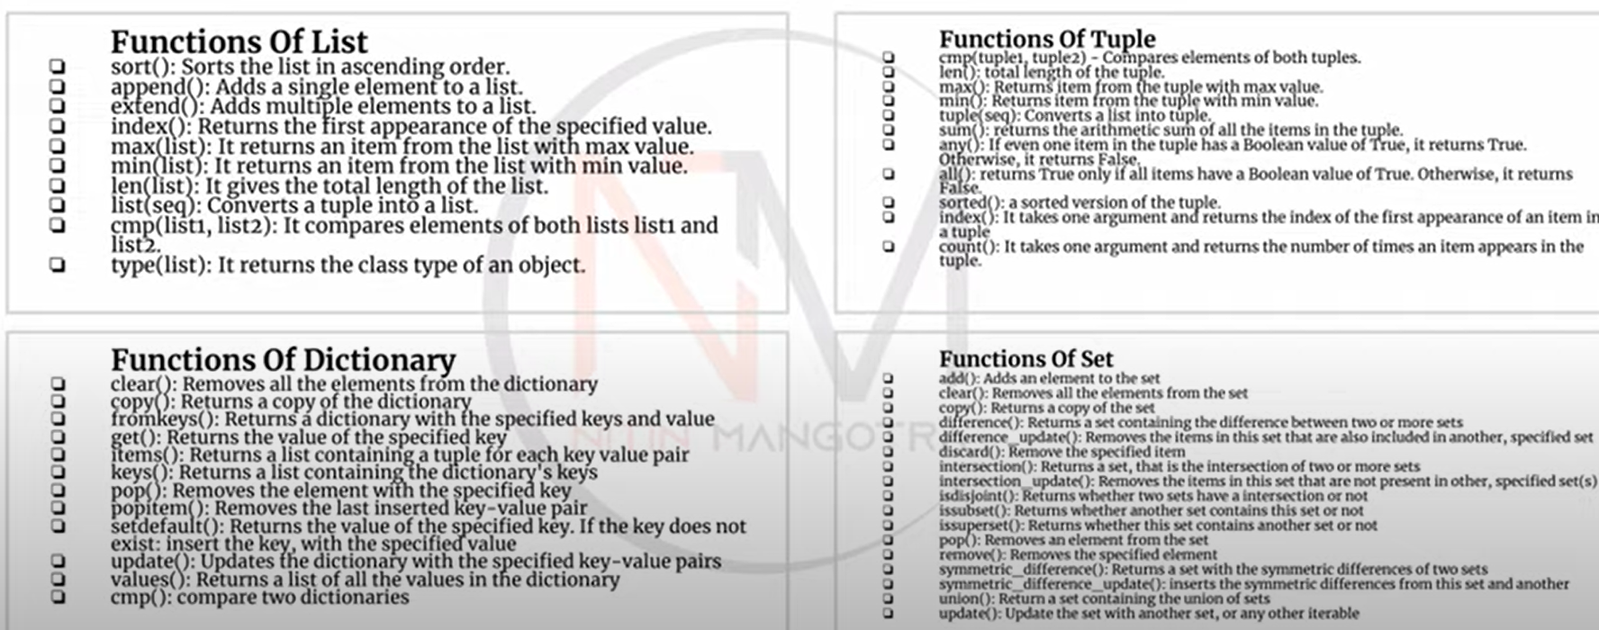

Sure! Here's a brief overview of each data structure in Python along with an example:

**1. List**

A list is an ordered collection of items that can be changed (mutable). Lists are defined using square brackets [].

**Example:**

fruits = ["apple", "banana", "cherry"]

fruits.append("orange") # Adding an item to the list

print(fruits) # Output: ['apple', 'banana', 'cherry', 'orange']

**2. Tuple**

A tuple is an ordered collection of items that cannot be changed (immutable). Tuples are defined using parentheses ().

**Example:**

coordinates = (10, 20, 30)

print(coordinates) # Output: (10, 20, 30)

**3. Set**

A set is an unordered collection of unique items. Sets are defined using curly braces {}.

**Example:**

unique_numbers = {1, 2, 3, 4, 4, 5}

print(unique_numbers) # Output: {1, 2, 3, 4, 5} # Duplicate '4' is removed

**4. Dictionary**

A dictionary is an unordered collection of key-value pairs. Dictionaries are defined using curly braces {} with key-value pairs separated by colons :.

**Example:**

student = {"name": "John", "age": 20, "grade": "A"}

student["age"] = 21 # Updating the value of a key

print(student) # Output: {'name': 'John', 'age': 21, 'grade': 'A'}

Each of these data structures serves different purposes and is useful in various scenarios. Do you have any specific questions about them?

1. Explain type conversions in python (int, float, str, oct …ect)

Type conversions in Python allow you to convert one data type to another. Here are some common type conversions:

**1. Integer (int)**

Converts a value to an integer.

x = int(3.14) # Converts float to int

print(x) # Output: 3

**2. Float (float)**

Converts a value to a floating-point number.

y = float("3.14") # Converts string to float

print(y) # Output: 3.14

**3. String (str)**

Converts a value to a string.

z = str(123) # Converts int to string

print(z) # Output: '123'

**4. Octal (oct)**

Converts an integer to an octal string.

octal_value = oct(10) # Converts int to octal string

print(octal_value) # Output: '0o12'

**5. Hexadecimal (hex)**

Converts an integer to a hexadecimal string.

hex_value = hex(255) # Converts int to hexadecimal string

print(hex_value) # Output: '0xff'

**6. Binary (bin)**

Converts an integer to a binary string.

binary_value = bin(10) # Converts int to binary string

print(binary_value) # Output: '0b1010'

**7. Boolean (bool)**

Converts a value to a boolean.

bool_value = bool(1) # Converts int to boolean

print(bool_value) # Output: True

These conversions are useful when you need to change the type of a variable to perform certain operations or to meet the requirements of a function. Do you have any specific type conversion in mind that you'd like to know more about?

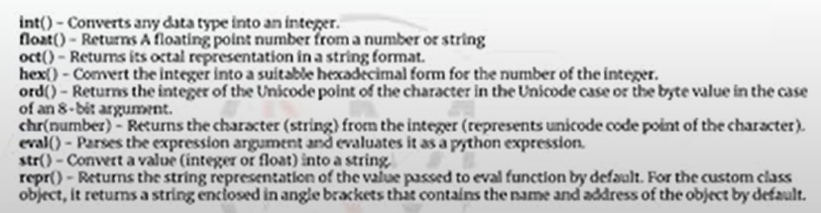

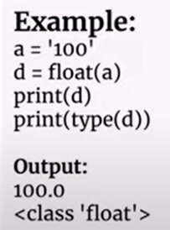 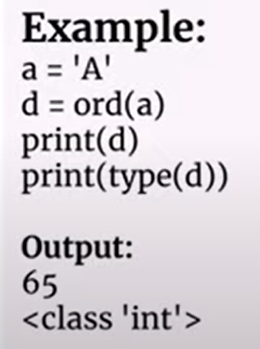

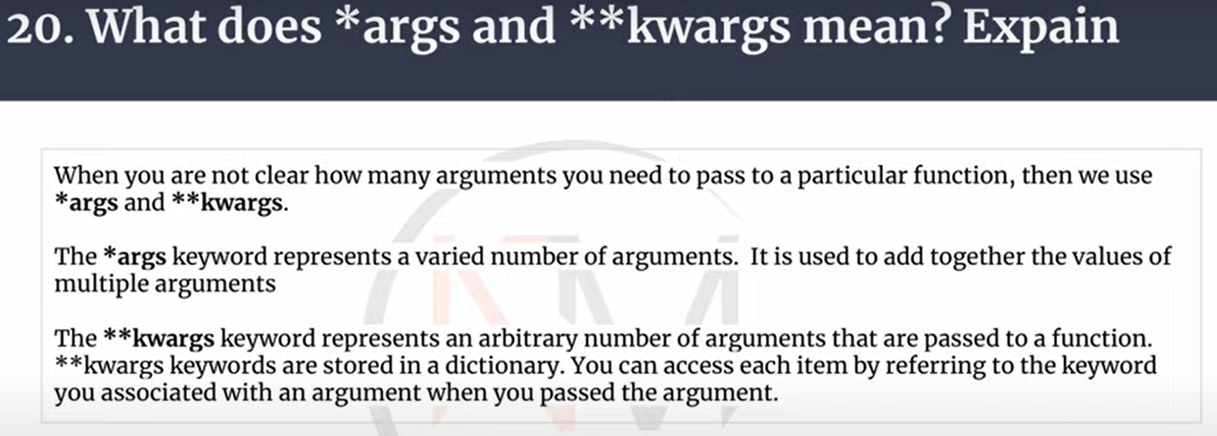

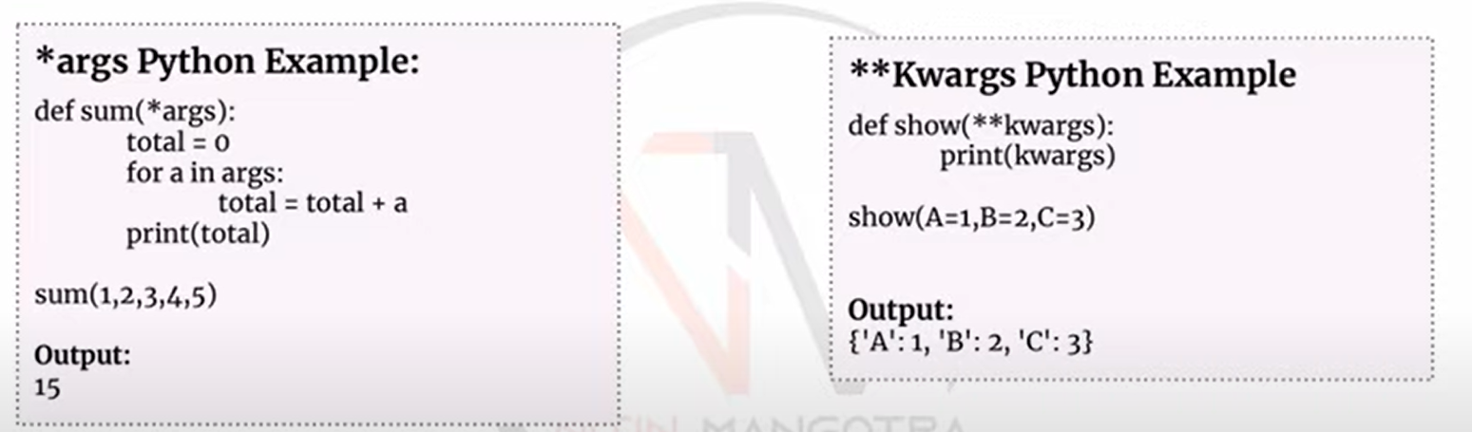

1. **What is Open and with statement in python ?**

**open Function**

The open function in Python is used to open a file and returns a file object, which allows you to read from or write to the file. The syntax is:

file_object = open("filename", "mode")

* **filename**: The name of the file you want to open.
* **mode**: The mode in which you want to open the file. Common modes include:
  + 'r': Read (default mode)
  + 'w': Write (creates a new file or truncates an existing file)
  + 'a': Append (adds to the end of the file)
  + 'b': Binary mode (e.g., 'rb' for reading binary files)

**Example:**

file = open("example.txt", "r")

content = file.read()

print(content)

file.close() # Always close the file after you're done

**with Statement**

The with statement in Python is used to wrap the execution of a block of code. It is commonly used with file operations to ensure that resources are properly managed. When used with open, it automatically closes the file when the block of code is exited, even if an exception occurs.

**Example:**

with open("example.txt", "r") as file:

content = file.read()

print(content)

# No need to explicitly close the file; it's done automatically

Using the with statement is considered best practice for file operations because it ensures that resources are properly managed and reduces the risk of file corruption or data loss.

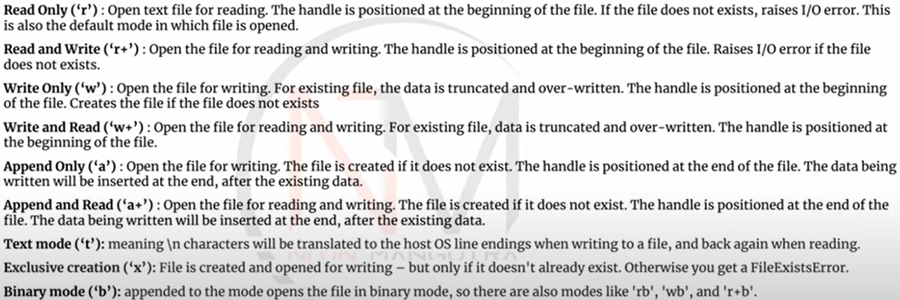

1. **What is python path**

The Python path is a list of directories that Python searches when looking for modules to import. This path is stored in the sys.path variable, which is part of the sys module. The Python path includes directories such as the directory containing the input script, the Python standard library, and any additional directories specified by the user.

**Examples of Python Path**

**1. Viewing the Python Path:** You can view the current Python path using the sys.path variable.

import sys

print(sys.path)

**2. Adding a Directory to the Python Path:** You can add a new directory to the Python path at runtime.

import sys

sys.path.append('/path/to/your/module')

**3. Using PYTHONPATH Environment Variable:** You can set the PYTHONPATH environment variable to include additional directories before starting Python.

export PYTHONPATH=/path/to/your/module

**4. Example of Importing a Module from a Custom Path:** Suppose you have a module in a custom directory, you can add that directory to the Python path and then import the module.

import sys

sys.path.append('/path/to/your/module')

import your_module

**Practical Use Cases**

* **Custom Modules:** When you have custom modules stored in different directories, you can add those directories to the Python path to import the modules easily.
* **Project Structure:** In large projects, you might organize your code into multiple directories. Adding these directories to the Python path helps in managing imports efficiently.
* **Virtual Environments:** Virtual environments often modify the Python path to include packages installed in the environment.

Would you like to know more about managing Python paths or any specific use case?

1. How exception is handled in python

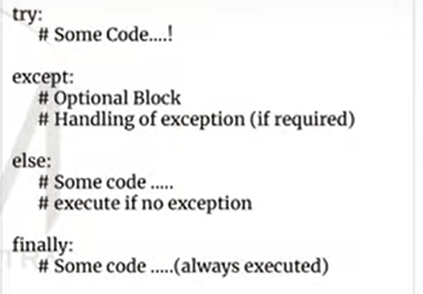

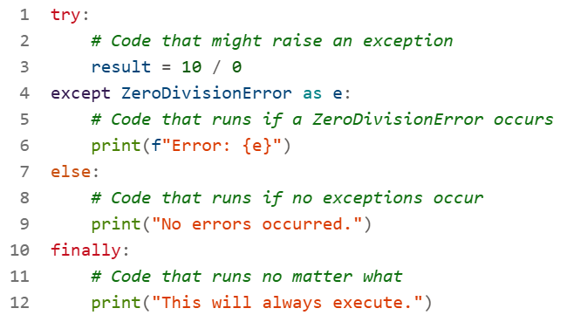

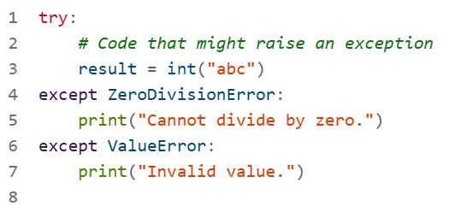

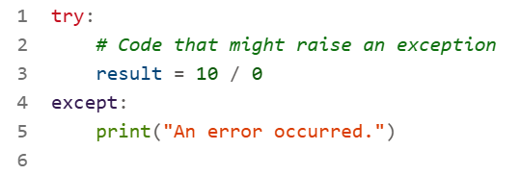

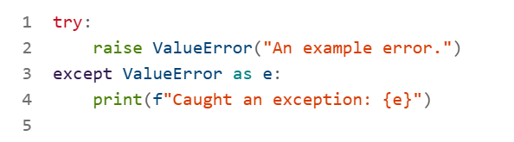

1. What are difference between python 2.0 and python 3.0

Python 2.0 and Python 3.0 have several key differences that affect how code is written and executed. Here are some of the main differences:

**1. Print Statement vs. Print Function**

* **Python 2:** Uses the print statement without parentheses.

print "Hello, World!"

* **Python 3:** Uses the print function with parentheses.

print("Hello, World!")

**2. Integer Division**

* **Python 2:** The / operator performs integer division if both operands are integers.

result = 5 / 2 # Output: 2

* **Python 3:** The / operator always performs float division.

result = 5 / 2 # Output: 2.5

For integer division, use the // operator.

result = 5 // 2 # Output: 2

**3. Unicode**

* **Python 2:** Strings are ASCII by default, and Unicode strings require a u prefix.

unicode_string = u"Hello, World!"

* **Python 3:** Strings are Unicode by default.

unicode_string = "Hello, World!"

**4. Exception Handling**

* **Python 2:** Uses a comma to separate the exception type and the variable.

try:

# Code that might raise an exception

pass

except ValueError, e:

print e

* **Python 3:** Uses the as keyword.

try:

# Code that might raise an exception

pass

except ValueError as e:

print(e)

**5. Input Function**

* **Python 2:** Uses raw_input() for reading input as a string and input() for evaluating the input.

name = raw_input("Enter your name: ")

age = input("Enter your age: ")

* **Python 3:** Uses input() for reading input as a string.

name = input("Enter your name: ")

age = input("Enter your age: ")

**6. Libraries and Compatibility**

* **Python 2:** Many libraries were initially written for Python 2, but support has dwindled since its end of life in 2020
* **Python 3:** Most modern libraries are written for Python 3, which is the recommended version for new projects

**7. Syntax and Features**

* **Python 3:** Introduced several new features and syntax improvements, such as type hints, f-strings for formatting, and more consistent behavior across the language

Python 3 is the future of the language, and it's recommended for new projects due to its improved features and better performance [[2]](https://www.datacamp.com/blog/python-2-vs-3-everything-you-need-to-know). Python 2 reached its end of life in 2020, meaning it no longer receives updates or security patches

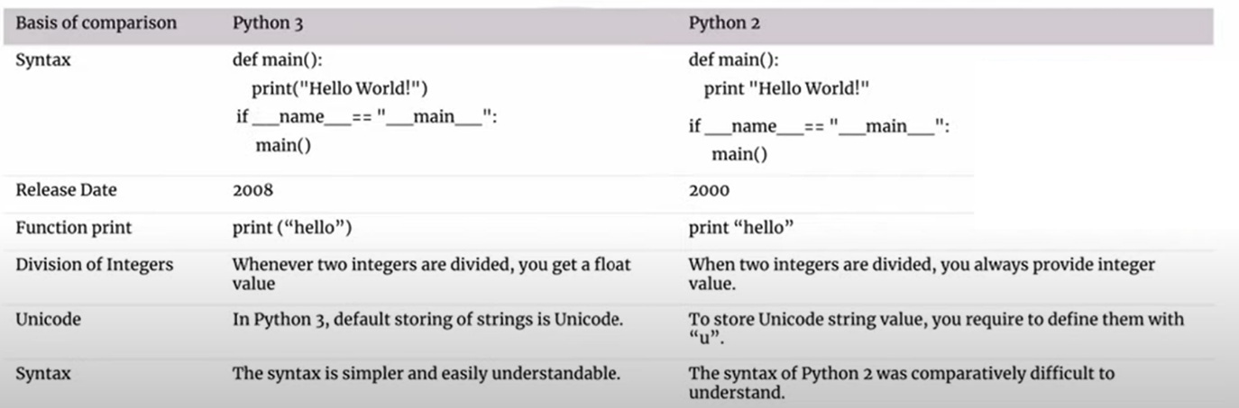

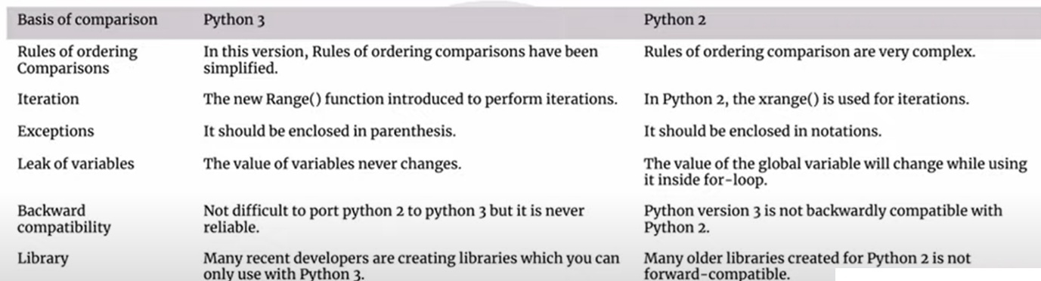

1. **What is pip in python**

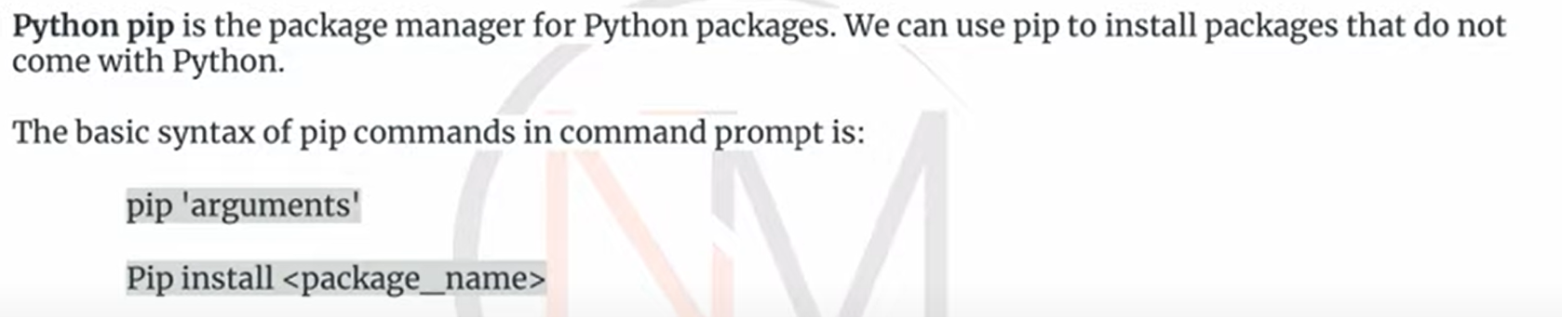

**pip** is the package installer for Python. It allows you to install and manage additional libraries and dependencies that are not included in the standard Python library. Here are some key points about pip:

**Key Functions of pip:**

**Installing Packages**: You can install packages from the Python Package Index (PyPI) and other repositories.

pip install package_name

**Upgrading Packages**: You can upgrade installed packages to their latest versions.

pip install --upgrade package_name

**Uninstalling Packages**: You can remove installed packages.

pip uninstall package_name

**Listing Installed Packages**: You can list all installed packages and their versions.

pip list

**Checking for Outdated Packages**: You can check which installed packages have newer versions available.

pip list --outdated

**Example Usage:**

**Installing a Package:**

pip install requests

This command installs the requests library, which is used for making HTTP requests.

**Upgrading a Package:**

pip install --upgrade requests

This command upgrades the requests library to the latest version.

**Uninstalling a Package:**

pip uninstall requests

This command removes the requests library from your environment.

**Configuration and Requirements:**

**Requirements File**: You can use a requirements.txt file to specify a list of packages to be installed.

pip install -r requirements.txt

The requirements.txt file might look like this:

requests==2.25.1

numpy==1.19.5

**Virtual Environments:**

pip works well with virtual environments, which allow you to create isolated Python environments for different projects. This helps manage dependencies and avoid conflicts.

1. How to use F-String and Format/replacement operator in python?

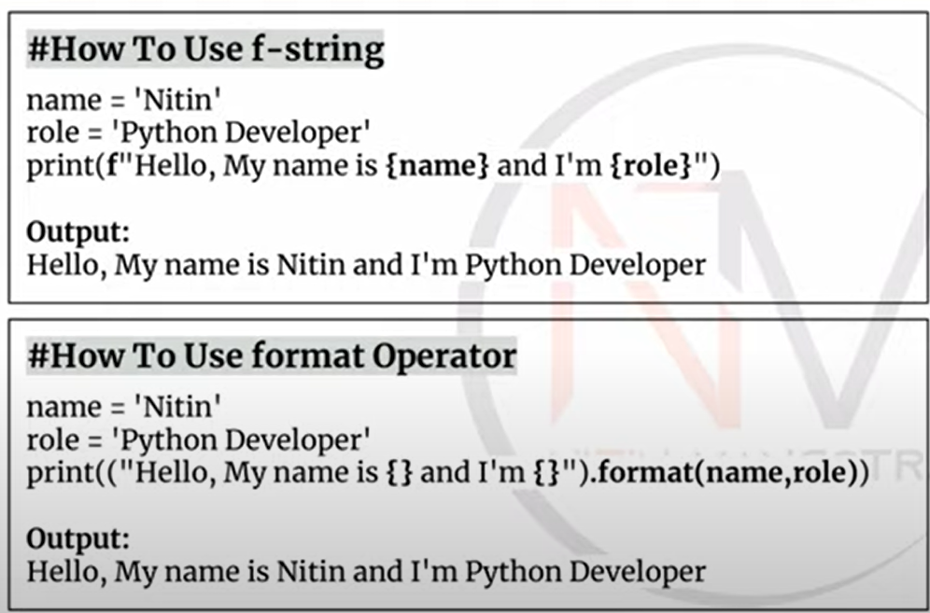

1. How to get all keys in a dictionary?

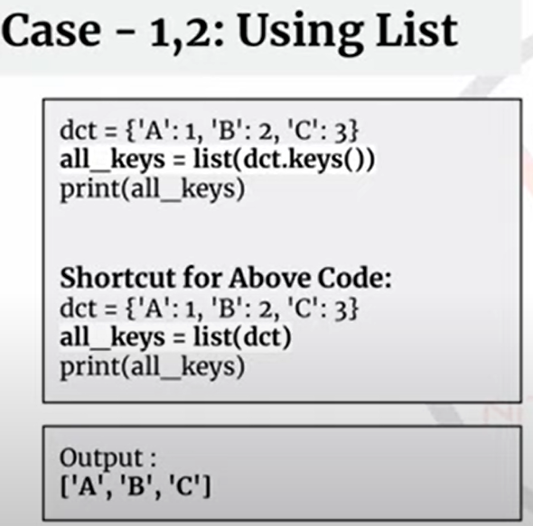

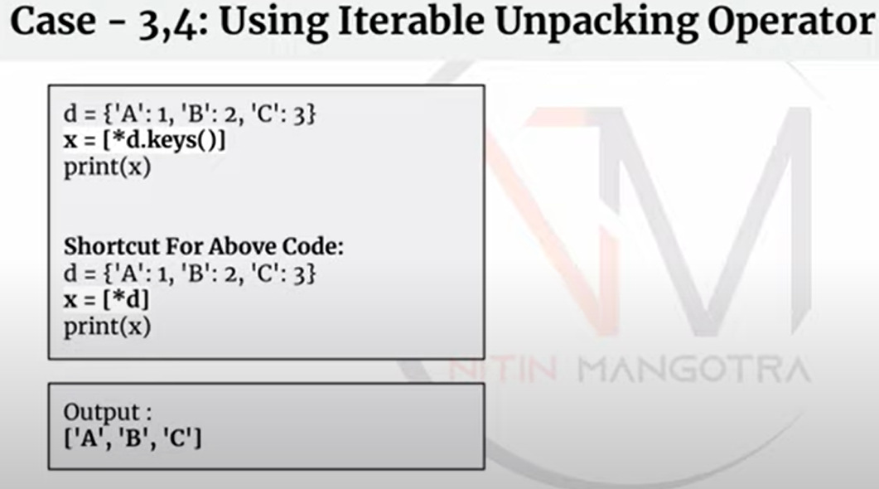

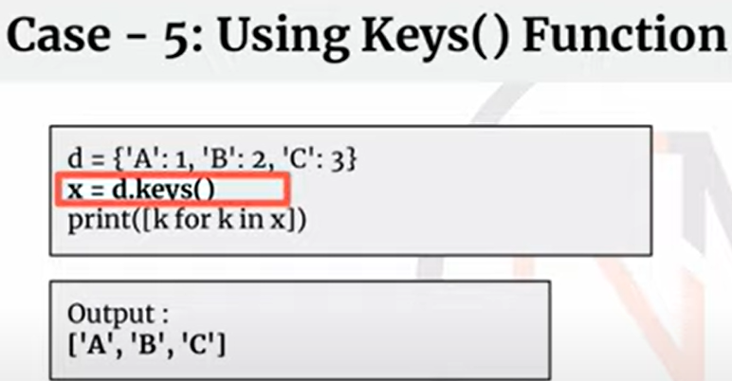

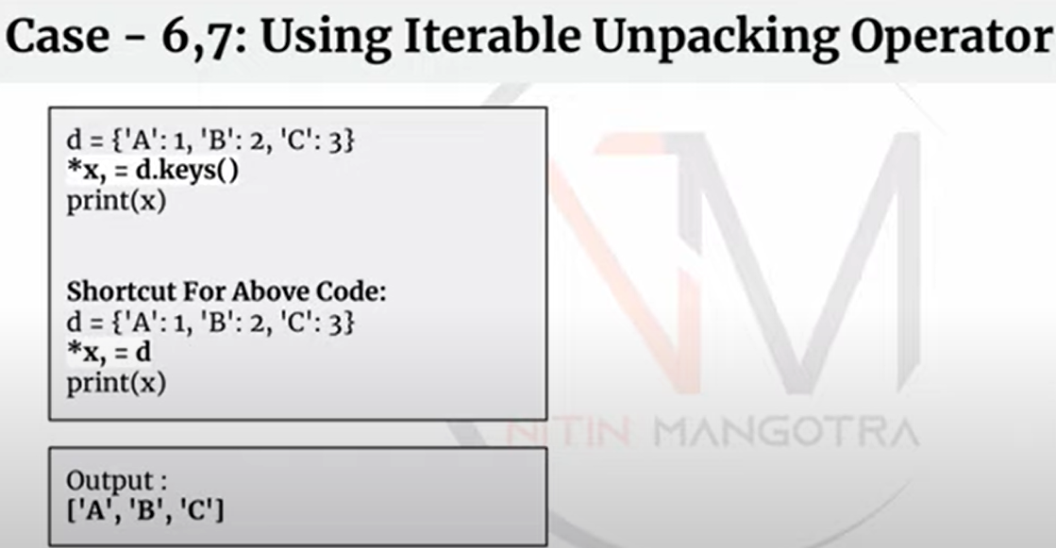

1. What is difference between Abstraction and Encapsulation

**Abstraction**

Abstraction is the concept of hiding the complex implementation details and showing only the necessary features of an object. It helps in reducing programming complexity and effort. In Python, abstraction can be achieved using abstract classes and interfaces.

**Example:**

from abc import ABC, abstractmethod

class Animal(ABC):

@abstractmethod

def sound(self):

pass

class Dog(Animal):

def sound(self):

return "Bark"

class Cat(Animal):

def sound(self):

return "Meow"

# Creating objects

dog = Dog()

cat = Cat()

print(dog.sound()) # Output: Bark

print(cat.sound()) # Output: Meow

In this example, the Animal class is an abstract class with an abstract method sound(). The Dog and Cat classes implement the sound() method, providing specific details.

**Encapsulation**

Encapsulation is the concept of wrapping data and methods that operate on the data within a single unit, typically a class. It restricts direct access to some of the object's components, which can prevent accidental modification of data. Encapsulation is achieved using private and protected access modifiers.

**Example:**

class Person:

def __init__(self, name, age):

self.__name = name # Private attribute

self.__age = age # Private attribute

def get_name(self):

return self.__name

def get_age(self):

return self.__age

def set_age(self, age):

if age > 0:

self.__age = age

# Creating an object

person = Person("John", 30)

# Accessing private attributes via public methods

print(person.get_name()) # Output: John

print(person.get_age()) # Output: 30

# Modifying private attribute via public method

person.set_age(31)

print(person.get_age()) # Output: 31

In this example, the Person class encapsulates the name and age attributes, making them private. Access to these attributes is provided through public methods get_name(), get_age(), and set_age().

**Key Differences:**

* **Abstraction** focuses on hiding the complex implementation details and exposing only the necessary parts.
* **Encapsulation** focuses on bundling the data and methods that operate on the data within a single unit and restricting access to the data.

Both concepts are fundamental to object-oriented programming and help in building robust and maintainable code.

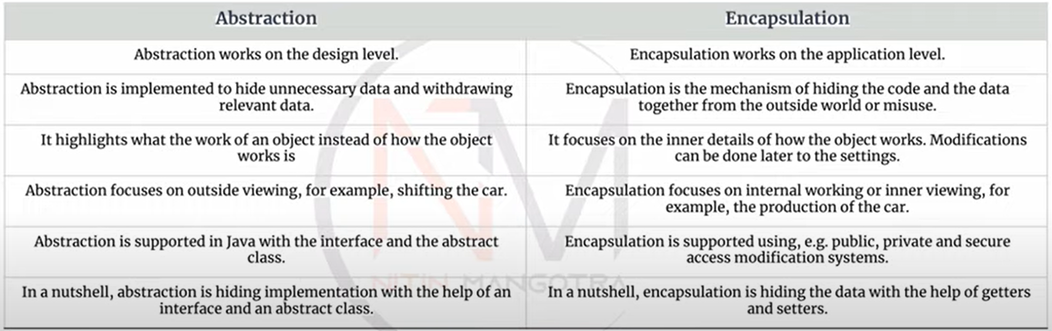

1. Does python support multiple Inheritance

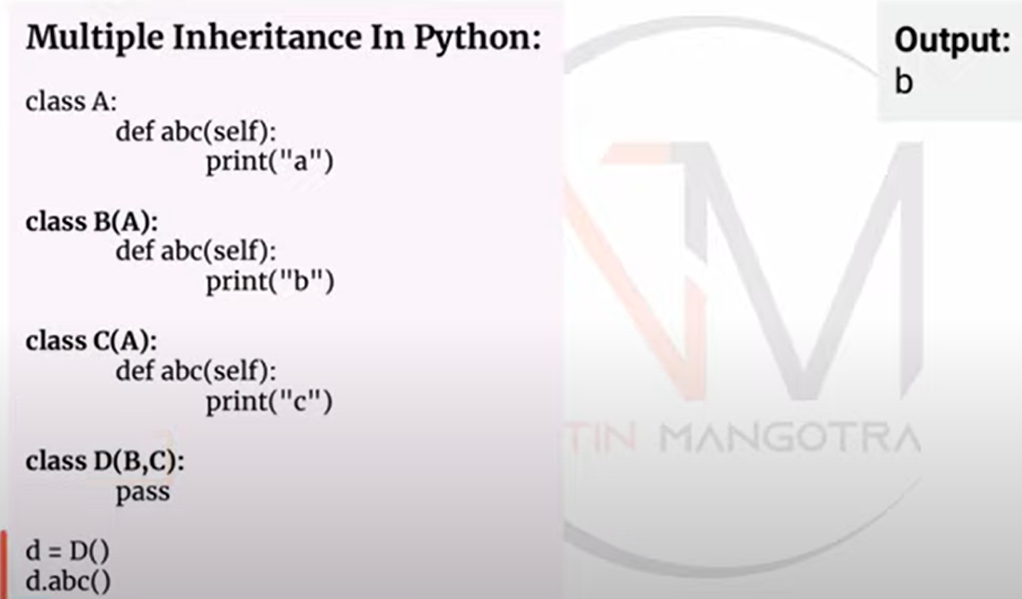

1. How to set empty List, Tuple, dict and set

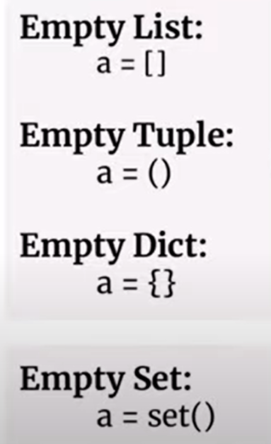

1. What is the difference between PY and PYC file?

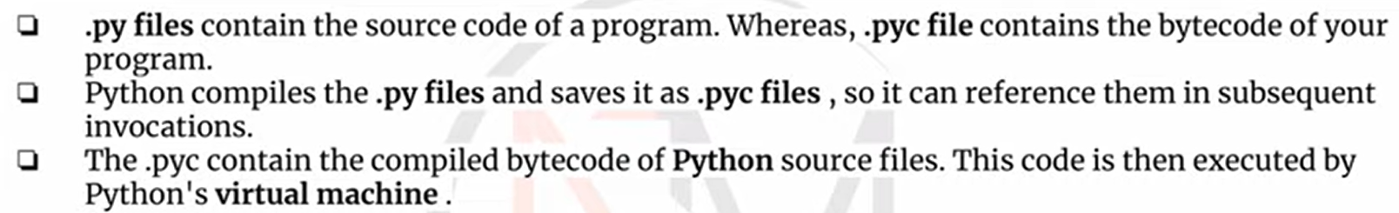

1. **How Slicing works in String Manipulation**

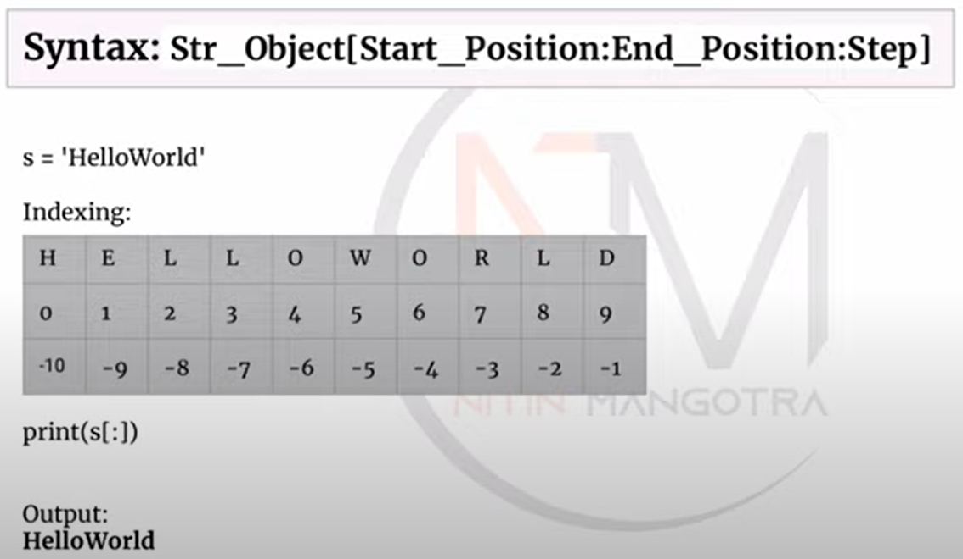



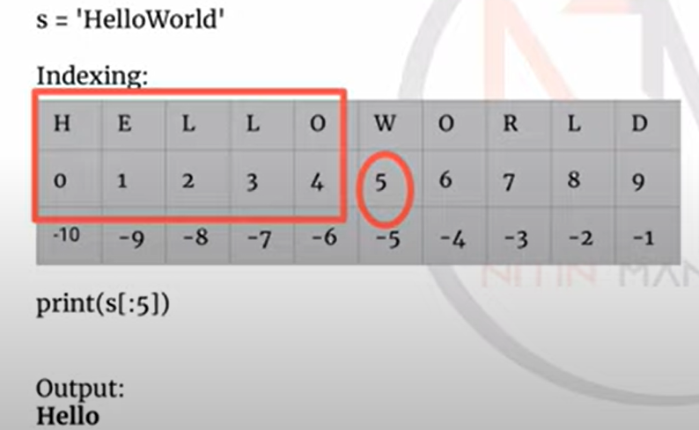

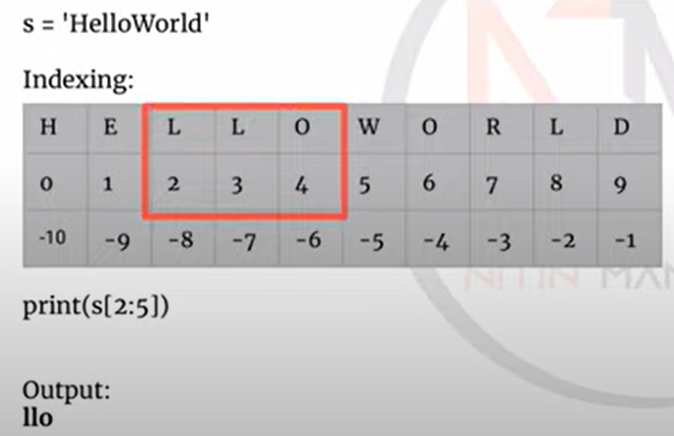

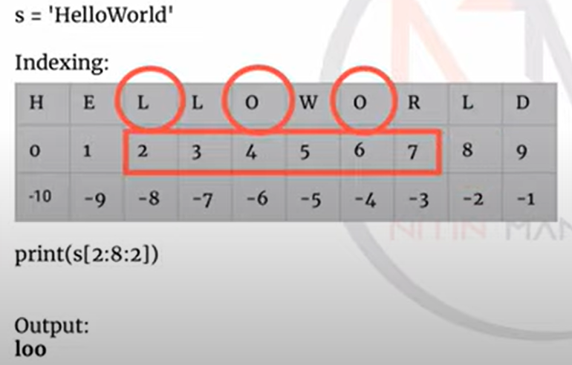

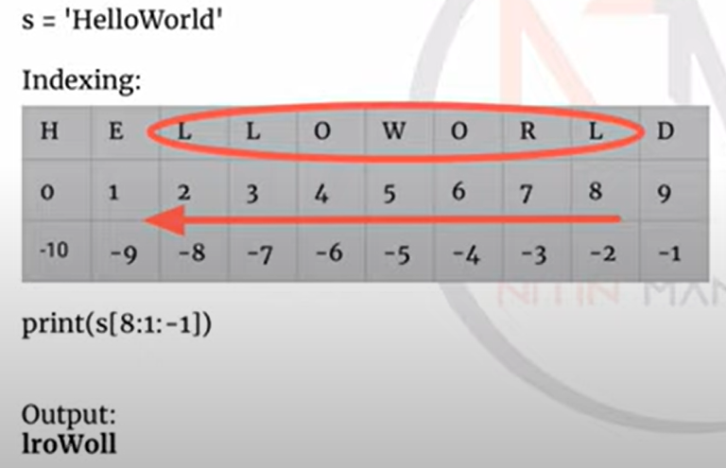

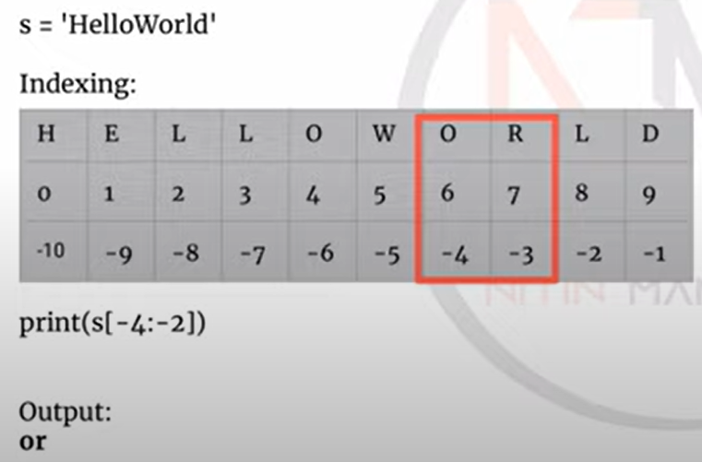

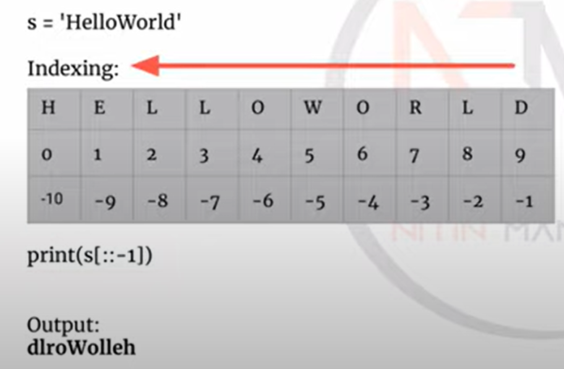

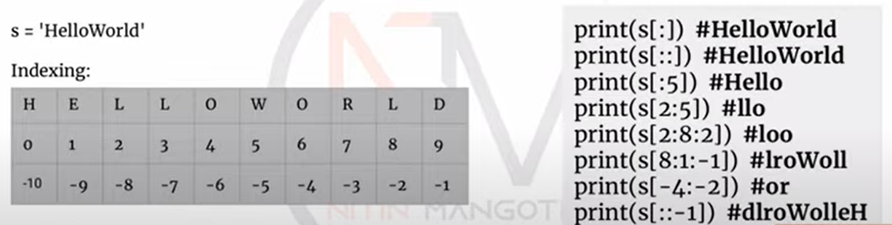

1. What is difference between Array and List

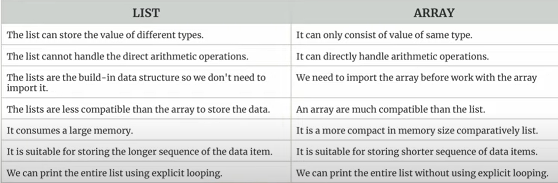

1. How to read multiple values from Single input?

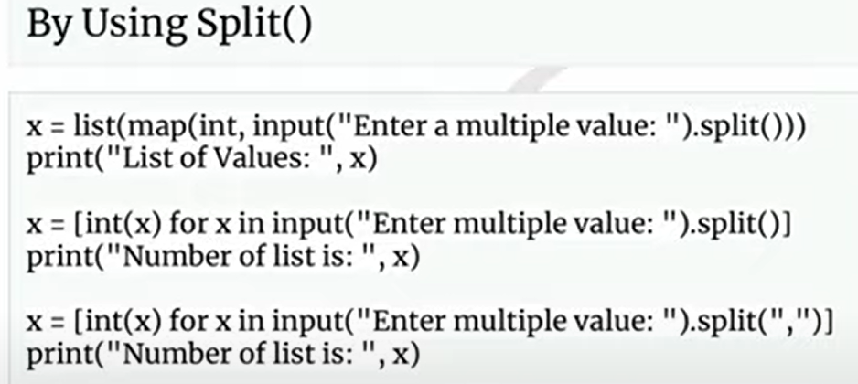

How to copy and delete a dictionary

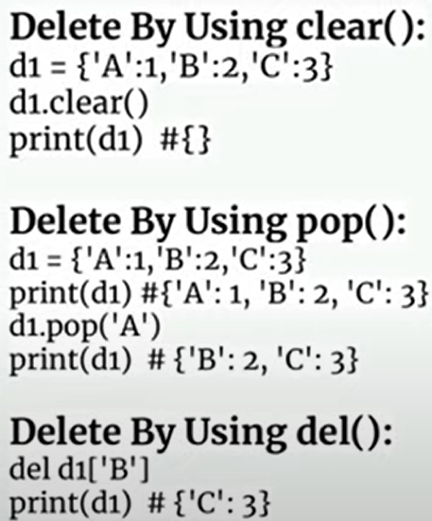 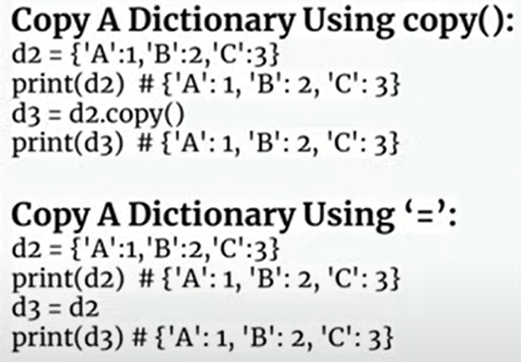

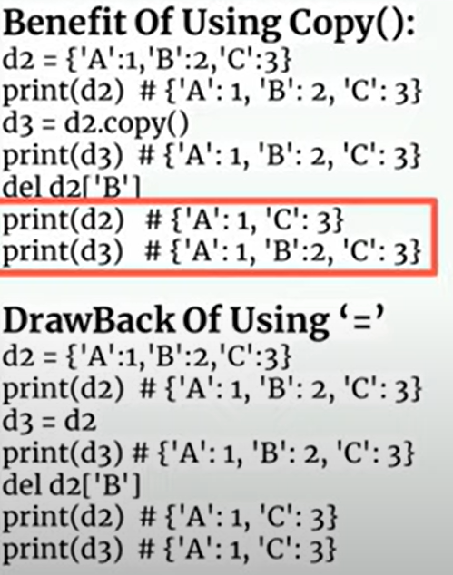

1. Difference between Lambda and Anonymous functions

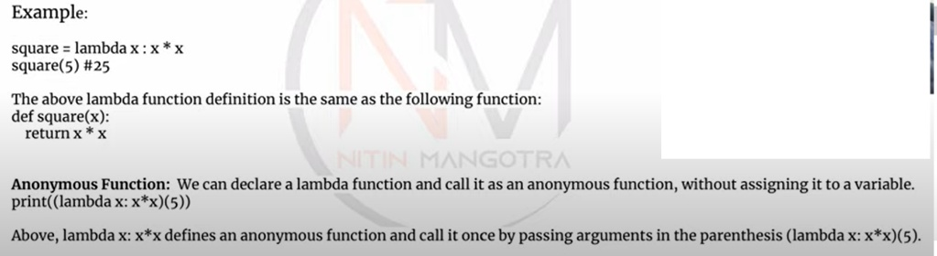

1. **What is multiprocessing and multithreading in python.**

**Multiprocessing** and **multithreading** are two techniques used to achieve concurrent execution in Python, allowing programs to perform multiple tasks simultaneously.

**Multiprocessing**

* **Definition**: Multiprocessing involves running multiple processes, each with its own Python interpreter and memory space.
* **Advantages**: It can bypass the Global Interpreter Lock (GIL), making it suitable for CPU-bound tasks.
* **Usage**: Ideal for tasks that require heavy computation, such as data processing or scientific calculations.
* **Example**:

from multiprocessing import Process

def print_square(num):

print(f'Square: {num * num}')

if __name__ == "__main__":

p = Process(target=print_square, args=(10,))

p.start()

p.join()

**Multithreading**

* **Definition**: Multithreading involves running multiple threads within the same process, sharing the same memory space.
* **Advantages**: Useful for I/O-bound tasks, such as network operations or file reading/writing.
* **Usage**: Suitable for tasks that spend a lot of time waiting for external resources.
* **Example**:

import threading

def print_square(num):

print(f'Square: {num * num}')

if __name__ == "__main__":

t = threading.Thread(target=print_square, args=(10,))

t.start()

t.join()

Both techniques can help improve the performance of your Python programs, depending on the nature of the tasks you're working with. Do you have a specific use case in mind?

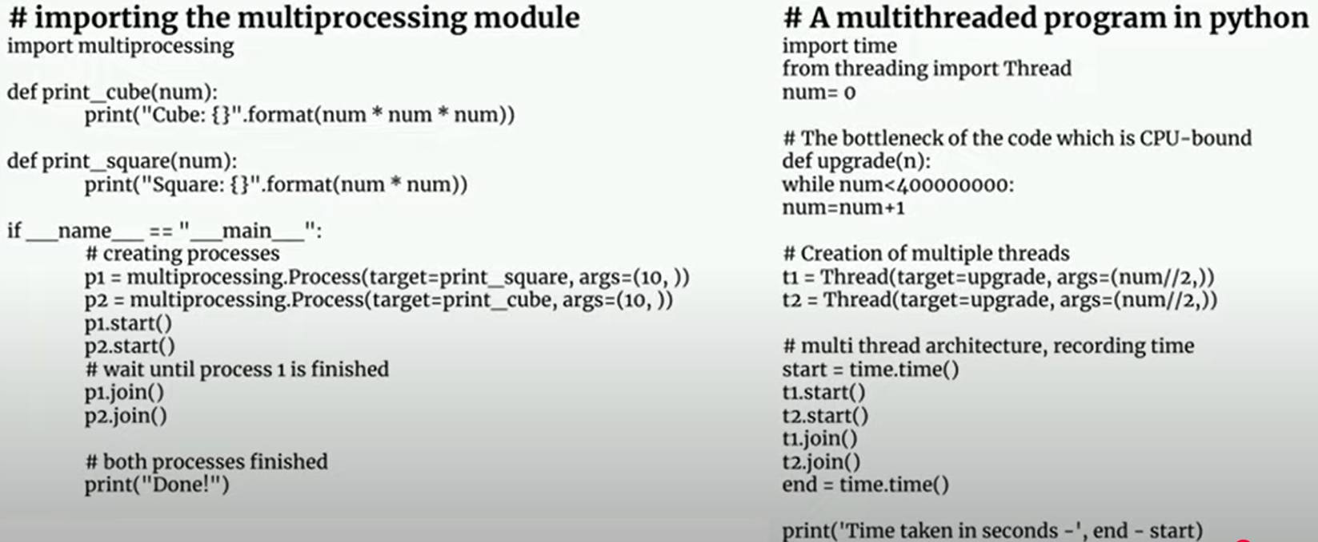

1. **Difference between Shallow copy and Deep Copy**

In Python, **shallow copy** and **deep copy** are two ways to duplicate objects, but they handle nested objects differently.

**Shallow Copy**

* **Definition**: A shallow copy creates a new object but inserts references into it to the objects found in the original.
* **Behavior**: Changes to nested objects in the copied object will affect the original object.
* **Usage**: Suitable when you need a copy of the top-level structure but don't need to duplicate nested objects.
* **Example**:

import copy

original_list = [1, [2, 3], 4]

shallow_copy = copy.copy(original_list)

shallow_copy[1][0] = 'changed'

print(original_list) # Output: [1, ['changed', 3], 4]

**Deep Copy**

* **Definition**: A deep copy creates a new object and recursively copies all objects found in the original.
* **Behavior**: Changes to nested objects in the copied object will not affect the original object.
* **Usage**: Suitable when you need a completely independent copy of the original object, including all nested objects.
* **Example**:

import copy

original_list = [1, [2, 3], 4]

deep_copy = copy.deepcopy(original_list)

deep_copy[1][0] = 'changed'

print(original_list) # Output: [1, [2, 3], 4]

**Summary**

* **Shallow Copy**: Copies the structure but not the nested objects.
* **Deep Copy**: Copies the structure and all nested objects.

1. **What is Operator Overloading and Dunder Method**

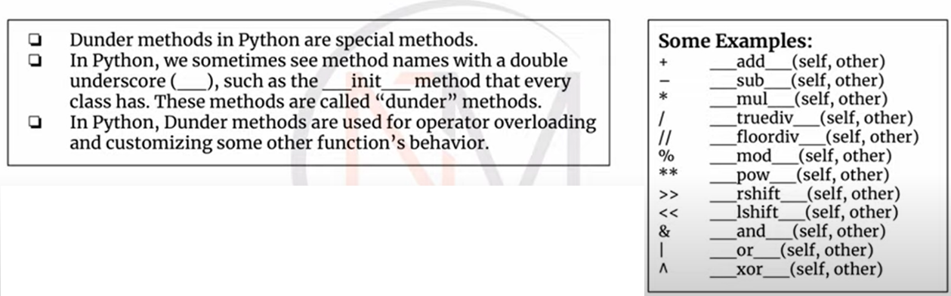

1. **What are the Python provides several built-in decorators.**

Python provides several built-in decorators that are commonly used to enhance the functionality of classes and functions. Here are some of the most frequently used ones:

**1. @staticmethod**

Defines a static method that does not receive an implicit first argument (neither self nor cls). It behaves like a plain function but belongs to the class's namespace.

class MyClass:

@staticmethod

def static_method():

print("This is a static method.")

MyClass.static_method() # Output: This is a static method.

**2. @classmethod**

Defines a class method that receives the class (cls) as its first argument. It can access class variables and other class methods.

class MyClass:

class_variable = "Hello, Class!"

@classmethod

def class_method(cls):

return cls.class_variable

print(MyClass.class_method()) # Output: Hello, Class!

**3. @property**

Defines a method as a property, allowing you to access it like an attribute. It is often used to create getter methods.

class MyClass:

def __init__(self, value):

self._value = value

@property

def value(self):

return self._value

my_instance = MyClass(10)

print(my_instance.value) # Output: 10

**4. @functools.lru_cache**

Caches the results of a function to improve performance, especially for expensive or frequently called functions.

import functools

@functools.lru_cache(maxsize=128)

def expensive_function(num):

print(f"Computing {num}...")

return num * num

print(expensive_function(4)) # Output: Computing 4... 16

print(expensive_function(4)) # Output: 16 (cached result)

**5. @dataclass**

Simplifies the creation of classes by automatically generating special methods like __init__, __repr__, and __eq__.

from dataclasses import dataclass

@dataclass

class MyDataClass:

name: str

age: int

person = MyDataClass(name="Alice", age=30)

print(person) # Output: MyDataClass(name='Alice', age=30)

1. **Python, what is class mapper**

In Python, a class mapper is typically used to map data between different object types, often in multi-layered architectures like data layers and presentation layers. This can be particularly useful when you need to convert data from one format to another, such as from a database model to a view model.

One popular library for this purpose is py-automapper. Here's a brief example of how it works:

from automapper import mapper

class UserInfo:

def __init__(self, name: str, profession: str, age: int):

self.name = name

self.profession = profession

self.age = age

class PublicUserInfo:

def __init__(self, name: str, profession: str):

self.name = name

self.profession = profession

# Create an instance of UserInfo

user_info = UserInfo("John Malkovich", "engineer", 35)

# Map UserInfo to PublicUserInfo

public_user_info = mapper.to(PublicUserInfo).map(user_info)

print(vars(public_user_info))

In this example:

* UserInfo is the original class with all user details.
* PublicUserInfo is the target class with only public details.
* The mapper maps the fields from UserInfo to PublicUserInfo.

The output will be:

{'name': 'John Malkovich', 'profession': 'engineer'}

This approach helps in keeping different layers of your application decoupled and makes it easier to manage data transformations

PANDA - FAQs

1. **What is Pandas in Python?**

**Answer:** Pandas is an open-source Python library used for data manipulation and analysis. It provides data structures like Series and DataFrame to handle and analyze data efficiently.

1. **How do you quickly access the top 5 rows and last 5 rows of a Pandas DataFrame?**

**Example:**

import pandas as pd

# Creating a sample DataFrame

data = {'A': [1, 2, 3, 4, 5, 6, 7, 8, 9, 10]}

df = pd.DataFrame(data)

# Accessing the top 5 rows

print(df.head())

# Accessing the last 5 rows

print(df.tail())

**Answer:** Use the head() method to access the first 5 rows and the tail() method to access the last 5 rows.

1. **What is the difference between a Series and a DataFrame?**

**Answer:**

* **Series:** A one-dimensional labeled array capable of holding any data type.
* **DataFrame:** A two-dimensional labeled data structure with columns of potentially different types.

1. **How do you create a new column derived from existing columns in Pandas?**

**Example:**

import pandas as pd

# Creating a sample DataFrame

df = pd.DataFrame({'A': [1, 2, 3], 'B': [4, 5, 6]})

# Creating a new column 'C' as the sum of columns 'A' and 'B'

df['C'] = df['A'] + df['B']

print(df)

**Answer:** You can create a new column by performing operations on existing columns and assigning the result to a new column name.

1. **How do you handle missing data in a DataFrame?**

**Example:**

import pandas as pd

# Creating a sample DataFrame with missing values

df = pd.DataFrame({'A': [1, 2, None], 'B': [4, None, 6]})

# Filling missing values with a specific value

df.fillna(0, inplace=True)

print(df)

# Dropping rows with missing values

df.dropna(inplace=True)

print(df)

**Answer:** Use fillna() to replace missing values or dropna() to remove rows/columns with missing values.

1. **How do you merge two DataFrames in Pandas?**

**Example:**

import pandas as pd

# Creating two sample DataFrames

df1 = pd.DataFrame({'A': [1, 2], 'B': [3, 4]})

df2 = pd.DataFrame({'A': [1, 2], 'C': [5, 6]})

# Merging DataFrames on column 'A'

merged_df = pd.merge(df1, df2, on='A')

print(merged_df)

**Answer:** Use the merge() function to combine two DataFrames based on a common column.

1. **What is multi-indexing in Pandas?**

**Answer:** Multi-indexing allows you to have multiple levels of indexing in a DataFrame, which can be useful for hierarchical data.

1. **How do you group data in a DataFrame?**

**Example:**

import pandas as pd

# Creating a sample DataFrame

df = pd.DataFrame({'A': ['foo', 'bar', 'foo', 'bar'], 'B': [1, 2, 3, 4]})

# Grouping by column 'A' and calculating the sum of column 'B'

grouped_df = df.groupby('A').sum()

print(grouped_df)

**Answer:** Use the groupby() method to group data and perform aggregate operations like sum, mean, etc.

1. **How do you pivot a DataFrame?**

**Example:**

import pandas as pd

# Creating a sample DataFrame

df = pd.DataFrame({'A': ['foo', 'bar', 'foo', 'bar'], 'B': [1, 2, 3, 4], 'C': [5, 6, 7, 8]})

# Pivoting the DataFrame

pivot_df = df.pivot(index='A', columns='B', values='C')

print(pivot_df)

**Answer:** Use the pivot() method to reshape data based on column values.

1. **How do you concatenate DataFrames?**

**Example:**

import pandas as pd

# Creating two sample DataFrames

df1 = pd.DataFrame({'A': [1, 2], 'B': [3, 4]})

df2 = pd.DataFrame({'A': [5, 6], 'B': [7, 8]})

# Concatenating DataFrames

concat_df = pd.concat([df1, df2])

print(concat_df)

**Answer:** Use the concat() function to concatenate DataFrames along a particular axis.

These questions cover a range of basic to intermediate concepts in Pandas. If you need more advanced questions or have specific topics in mind, feel free to ask!

1. **How do you perform a groupby operation and calculate multiple aggregate functions on the grouped data?**

**Example:**

import pandas as pd

# Creating a sample DataFrame

df = pd.DataFrame({

'A': ['foo', 'bar', 'foo', 'bar', 'foo', 'bar'],

'B': [1, 2, 3, 4, 5, 6],

'C': [7, 8, 9, 10, 11, 12]

})

# Grouping by column 'A' and calculating multiple aggregate functions

grouped_df = df.groupby('A').agg({'B': ['mean', 'sum'], 'C': ['max', 'min']})

print(grouped_df)

**Answer:** Use the agg() method to apply multiple aggregate functions on grouped data.

1. **How do you handle time series data in Pandas?**

**Example:**

import pandas the index

df.set_index('date', inplace=True)

# Resampling the data to weekly frequency and calculating the sum

resampled_df = df.resample('W').sum()

print(resampled_df)

**Answer:** Use the resample() method to handle time series data and perform operations like aggregation.

1. **How do you merge DataFrames with different column names?**

**Example:**

import pandas as pd

# Creating two sample DataFrames with different column names

df1 = pd.DataFrame({'key1': [1, 2], 'value1': [3, 4]})

df2 = pd.DataFrame({'key2': [1, 2], 'value2': [5, 6]})

# Merging DataFrames on different column names

merged_df = pd.merge(df1, df2, left_on='key1', right_on='key2')

print(merged_df)

**Answer:** Use the left_on and right_on parameters in the merge() function to merge DataFrames with different column names.

1. **How do you pivot a DataFrame with multiple index levels?**

**Example:**

import pandas as pd

# Creating a sample DataFrame

df = pd.DataFrame({

'A': ['foo', 'foo', 'bar', 'bar'],

'B': ['one', 'two', 'one', 'two'],

'C': [1, 2, 3, 4]

})

# Pivoting the DataFrame with multiple index levels

pivot_df = df.pivot_table(values='C', index=['A', 'B'])

print(pivot_df)

**Answer:** Use the pivot_table() method to pivot a DataFrame with multiple index levels.

1. **How do you apply a custom function to a DataFrame using apply()?**

**Example:**

import pandas as pd

# Creating a sample DataFrame

df = pd.DataFrame({'A': [1, 2, 3], 'B': [4, 5, 6]})

# Defining a custom function

def custom_func(x):

return x * 2

# Applying the custom function to each element in the DataFrame

df = df.apply(custom_func)

print(df)

**Answer:** Use the apply() method to apply a custom function to each element in the DataFrame.

1. **How do you handle categorical data in Pandas?**

**\Example:**

import pandas as pd

# Creating a sample DataFrame with categorical data

df = pd.DataFrame({'A': ['foo', 'bar', 'foo', 'bar'], 'B': [1, 2, 3, 4]})

# Converting column 'A' to categorical type

df['A'] = df['A'].astype('category')

# Getting the codes and categories

print(df['A'].cat.codes)

print(df['A'].cat.categories)

**Answer:** Use the astype('category') method to convert a column to categorical type and access its codes and categories.

1. **How do you perform a rolling window calculation in Pandas?**

**Example:**

import pandas as pd

# Creating a sample DataFrame

df = pd.DataFrame({'A': [1, 2, 3, 4, 5, 6, 7, 8, 9, 10]})

# Calculating the rolling mean with a window size of 3

df['rolling_mean'] = df['A'].rolling(window=3).mean()

print(df)

**Answer:** Use the rolling() method to perform rolling window calculations like mean, sum, etc.

1. **How do you handle large datasets efficiently in Pandas?**

**Answer:**

* Use chunk_size parameter in read_csv() to read data in chunks.
* Use dtypes parameter to specify data types and reduce memory usage.
* Use query() method for efficient filtering.

1. **How do you perform a join operation with multiple keys?**

**Example:**

import pandas as pd

# Creating two sample DataFrames

df1 = pd.DataFrame({'key1': [1, 2], 'key2': ['a', 'b'], 'value1': [3, 4]})

df2 = pd.DataFrame({'key1': [1, 2], 'key2': ['a', 'b'], 'value2': [5, 6]})

# Performing a join operation with multiple keys

joined_df = pd.merge(df1, df2, on=['key1', 'key2'])

print(joined_df)

**Answer:** Use the on parameter with a list of keys in the merge() function to perform join operations with multiple keys.

1. **How do you optimize performance when working with large DataFrames?**

**Answer:**

* Use dtypes to reduce memory usage.
* Use query() for efficient filtering.
* Use chunk_size in read_csv() to read data in chunks.
* Use numexpr for faster numerical operations.

These advanced questions cover a range of topics that are often encountered in real-world data analysis scenarios. If you need more specific examples or have other questions, feel free to ask!

1. **What is difference between JOIN and MERGE**

In Pandas, both **join** and **merge** are used to combine DataFrames, but they have some differences in their usage and flexibility. Here's a breakdown of the key differences:

**merge**

* **Flexibility**: merge is more flexible and allows you to specify the columns to join on.
* **Syntax**: pd.merge(df1, df2, on='key', how='inner')
* **Join Types**: Supports various types of joins (inner, outer, left, right).
* **Column Specification**: You can specify which columns to join on using the on, left_on, and right_on parameters.
* **Suffixes**: Allows you to specify suffixes for overlapping column names using the suffixes parameter.

**Example:**

import pandas as pd

df1 = pd.DataFrame({

'key': ['A', 'B', 'C', 'D'],

'value': [1, 2, 3, 4]

})

df2 = pd.DataFrame({

'key': ['B', 'D', 'E', 'F'],

'value': [5, 6, 7, 8]

})

merged_df = pd.merge(df1, df2, on='key', how='inner', suffixes=('_df1', '_df2'))

print(merged_df)

**join**

* **Index-Based**: Primarily used for joining on the index.
* **Syntax**: df1.join(df2, how='inner')
* **Join Types**: Supports various types of joins (inner, outer, left, right).
* **Column Specification**: Typically joins on the index, but you can join on columns by setting them as the index first.
* **Suffixes**: Allows you to specify suffixes for overlapping column names using the lsuffix and rsuffix parameters.

**Example:**

import pandas as pd

df1 = pd.DataFrame({

'key': ['A', 'B', 'C', 'D'],

'value': [1, 2, 3, 4]

}).set_index('key')

df2 = pd.DataFrame({

'key': ['B', 'D', 'E', 'F'],

'value': [5, 6, 7, 8]

}).set_index('key')

joined_df = df1.join(df2, how='inner', lsuffix='_df1', rsuffix='_df2')

print(joined_df)

**Summary**

* **Use merge** when you need more control over the columns you are joining on and when you are not necessarily joining on the index.
* **Use join** when you are primarily working with DataFrames that have their indexes set and you want to join based on those indexes.

Both methods are powerful and can be used depending on the specific requirements of your data manipulation task. Let me know if you have any further questions!

**Join condition with where clause:**

import pandas as pd

# Create sample DataFrames

df1 = pd.DataFrame({

    'key': ['A', 'B', 'C', 'D'],

    'value1': [1, 2, 3, 4]

})

df2 = pd.DataFrame({

    'key': ['B', 'D', 'E', 'F'],

    'value2': [5, 6, 7, 8]

})

# Merge DataFrames with a condition

# Here, we want to join where the keys match and value1 is less than value2

merged_df = pd.merge(df1, df2, on='key', how='inner')

condition = merged_df['value1'] < merged_df['value2']

result = merged_df[condition]

print(result)

**PySpark / DataBricks**

**LAB**: <https://colab.research.google.com/>

<https://community.cloud.databricks.com/>

1. **Spark get find duplicate value from list**

from pyspark.sql import SparkSession

from pyspark.sql.functions import col

# Create a Spark session

spark = SparkSession.builder.appName("FindDuplicates").getOrCreate()

# Sample data

data = [("apple",), ("banana",), ("apple",), ("orange",), ("banana",), ("grape",)]

# Create a DataFrame

df = spark.createDataFrame(data, ["fruit"])

# Group by the 'fruit' column and count occurrences

df_grouped = df.groupBy("fruit").count()

# Filter to get only duplicates

duplicates = df_grouped.filter(col("count") > 1)

# Show the duplicates

duplicates.show()

# Stop the Spark session

spark.stop()

1. **Read data from parquet file**

from pyspark.sql import SparkSession

# Initialize Spark session

spark = SparkSession.builder.appName("ReadParquet").getOrCreate()

# Path to the Parquet file

parquet_file_path = "path/to/your/parquet/file.parquet"

# Read the Parquet file into a DataFrame

df = spark.read.parquet(parquet_file_path)

# Show the DataFrame

df.show()

1. analytical requirements in pyspark
2. how to ensure compile time safely
3. what is the largest dataset you worked in pyspark
4. project architecture of the previous project.
5. explain if there can be alternative architecture with tools and tech
6. Perforamance issues you faced in spark
7. Program execution of spark
8. oom in driver node issues
9. Count the occurrence of each element from a list. Write a program that a given list count the occurrence of each element   
   sample_list = [11, 45, 8, 11, 23, 45, 23, 45, 89]   
   Printing count of each item   {11: 2, 45: 3, 8: 1, 23: 2, 89: 1}

**SPARK FAQ**

What is repartition?s  
How you do repartition by a column?  
How spark handles when the application runs?  
If we want to reduce the time spark takes for a job, what could be the procedure?  
How you can debug a slow running spark?  
How do you handle uneven distribution in the partitions?  
What is broadcast?  
If two tables are large how spark handles the join operation?

Coding Question:::  
ProductId  Category  Units  SalesValue  
1001  1  10  1000  
1002  1  10  2000  
1003  1  10  3000  
1004  2  10  4000  
1005  2  10  2000  
1006  3  5  800  
1007  3  5  600  
1008  3  5  500  
1009  4  3  400  
1010  4  2  200  
1010  6  2  200  
1001  1  5  500  
1001  1  5  500  
1001  1  5  500  
1003  1  10  3000  
  
  
  
Category  Description  
1  Cat-1  
2  Cat-2  
3  Cat-3  
4  Cat-4  
5  Cat-5  
  
  
  
ProductId  Category  Units  SalesValue  CategoryTotalSales  
1001  1  10  1000  10500  
1002  1  10  2000  10500  
1003  1  10  3000  10500  
1004  2  10  4000  6000  
1005  2  10  2000  6000  
1006  3  5  800  1900  
1007  3  5  600  1900  
1008  3  5  500  1900  
1009  4  3  400  600  
1010  4  2  200  600  
1010  6  2  200  200  
1001  1  5  500  10500  
1001  1  5  500  10500  
1001  1  5  500  10500  
1003  1  10  3000  10500  
  
1. Join two tables Need to have all categories in second table and should have 0 as total sales value if it is not present in the first table.  
2. Create the last table.  
3. Following up get the category having second highest total sales.

1. what is decorator?write the python code for decorator

**Chauhan, Sanjay**

def myfunc --> sleep: 3mins.  
I want you write the decorators that print start and end time.

2. dataframe = (10, 22, 36, 22, 33, 36, 47, 51)  
   display the duplicate values using python code.  
3. Sales.parquet  
Ordr_id, Cust_id, Prod_Id, Quantity, Unit_Price  
1001, C01, P01, 2, 500  
1002, C02, P02, 1, 1500  
1003, C01, P01, 1, 500  
  
Prod.parquet  
Prod_Id, Prod_Name, Category  
P01, Smartphone, Electronics  
P02, Laptop Electronics  
P03, Notebook, Stationery

Write a pyspark code to join the two dataframes and display the prod_name column

4. what is global interpretor lock?  
5. What is the difference between module and package in python.  
6. Please describe the structure of packages in python.  
7. what is _ and __ in python?  
8. What is _init_.py and _main_ in python?

**Python interview questions**

1. Count the occurrence of each element from a list. Write a program that a given list count the occurrence of each element

sample_list = [11, 45, 8, 11, 23, 45, 23, 45, 89]

Printing count of each item {11: 2, 45: 3, 8: 1, 23: 2, 89: 1}

####################

def most_frequent_word(text: str) -> str:

words = text.lower().split()

freq = {}

for word in words:

freq[word] = freq.get(word, 0) + 1

return max(freq, key=freq.get)

# Test

print(most_frequent_word("Python is great and Python is easy"))

output

python

###############

##############

list1 = [199.99, 299.99, 199.99, 99.99, 149.99, 299.99, 99.99]

output should be [99.99, 149.99, 199.99, 299.99]

need to use set for removing duplicates & order of items, then convert to list

list1_s = list(set(list1))

print(list1_s)

######################

employees = [

{"name": "Alice", "salary": 88000},

{"name": "Bob", "salary": 68000},

{"name": "Charlie", "salary": 98000}

]

find emplyee name who gets max salary.

highest_paid = max(employees, key=lambda emp: emp["salary"])

print("Employee with highest salary:", highest_paid["name"])

Employee with highest salary: Charlie

####################

Decorator for Logging Function Calls

def logger(func):

def wrapper(*args, **kwargs):

print(f"Calling {func.__name__} with {args} and {kwargs}")

return func(*args, **kwargs)

return wrapper

@logger

def add(a, b):

return a + b

# Test

print(add(2, 3))

output

Calling add with (2, 3) and {}

5

####################

2. # Example usage

input_string = "Hello, World!"

result = count_characters(input_string)

# Print the results

for char, count in result.items():

print(f"'{char}': {count}")

input_string = "Hello, World!"

output

'H': 1

'e': 1

'l': 3

'o': 2

',': 1

' ': 1

'W': 1

'r': 1

'd': 1

'!': 1

#################

2. list_value =['0917895462130','919875641230','9195969878']

print last 10 digits of mobile number

for number in list_value:

print(number[-10:])

######################

3. #Python program to print a list

# without using the sort() function

# using an extra variable

l1=[76,23,45,12,54,9]

# Original list

l1 = [76, 23, 45, 12, 54, 9]

# Get the length of the list

n = len(l1)

# Sort using a basic selection sort algorithm

for i in range(n):

for j in range(i + 1, n):

if l1[i] > l1[j]:

# Use an extra variable to swap

temp = l1[i]

l1[i] = l1[j]

l1[j] = temp

# Print the sorted list

print("Sorted list without using sort():", l1)

Sorted list without using sort(): [9, 12, 23, 45, 54, 76]

###############

text = "Hello! This is test#123 with numbers 45.67 and symbols @$%."

# Extract words (alphanumeric sequences with letters)

words = re.findall(r'\b[a-zA-Z]+\b', text)

# Extract numbers (integers and floats)

numbers = re.findall(r'\b\d+\.?\d*\b', text)

# Extract special characters (non-alphanumeric and not whitespace)

special_chars = re.findall(r'[^\w\s]', text)

@@@

email_str = '''the emails are support@codecademy.com

or help@codecademy.com'''

emails = re.findall(r"\S+@\S+", email_str)

# ['support@codecademy.com', 'help@codecademy.com']

@@@

movie_str = "the evening shows start at 7:00pm and 10:15pm"

matches = re.findall(r"([\d:,.]+)(am|pm)?", movie_str)

[("7:00", "pm"), ("10:15", "pm")]

==================================

Given the .csv file students.csv with this content

school,class,name,date_Of_Birth,height,weight,address

s001, V,Alberto Franco,15/05/2002,173,35,street1

s002, V, Gino Mcneill,17/05/2002,192,32,street2

s003,VI, Ryan Parkes,16/02/1999,186,33,street3

s001,VI, Eesha Hinton,25/09/1998,167,30,street1

s002, V, Gino Mcneill,11/05/2002,151,31,street2

s004,VI, David Parkes,15/09/1997,159,32,street4

Write the needed code (using Pandas) to read the file and get:

The youngest student

Groups of students in the same school

The student who lives in street1 with highest weight

import pandas as pd

df = pd.read_csv("path_of_csv_file")

df['date_Of_Birth'] = pd.to_datetime(['date_Of_Birth',format='%d%M%Y')

youngest_student = df.loc[df['date_Of_Birth'].idxmax()]

grouped = df.groupby('school')

student_street = df[df['address']=='street1'.nlargest(1,'weight').iloc[0]

print("youngest_student:",youngest_student)

print("student_street:",student_street)

================================================

#########

Given this json

[{

"_id": {

"$oid": "5968dd23fc13ae04d9000001"

},

"product_name": "sildenafil citrate",

"supplier": "Wisozk Inc",

"quantity": 261,

"unit_cost": "$10.47"

}, {

"_id": {

"$oid": "5968dd23fc13ae04d9000002"

},

"product_name": "Mountain Juniperus ashei",

"supplier": "Keebler-Hilpert",

"quantity": 292,

"unit_cost": "$8.74"

}, {

"_id": {

"$oid": "5968dd23fc13ae04d9000003"

},

"product_name": "Dextromathorphan HBr",

"supplier": "Schmitt-Weissnat",

"quantity": 211,

"unit_cost": "$20.53"

}]

write the code needed to get

The id of the product with the highest quantity

The product name with the minimum unit cost

=

# Get the id of the product with the highest quantity

max_quantity_product = max(data, key=lambda x: x['quantity'])

max_quantity_id = max_quantity_product['_id']['$oid']

# Get the product name with the minimum unit cost

# Convert unit_cost from string to float for comparison

min_cost_product = min(data, key=lambda x: float(x['unit_cost'].replace('$', '')))

min_cost_product_name = min_cost_product['product_name']

print("ID of product with highest quantity:", max_quantity_id)

print("Product name with minimum unit cost:", min_cost_product_name)

++++++++++++++++++++++++++++++++++++++++++++++++++++++++++++++++++++

SQL Interview Questions

=======================

DDL Commands

DML Commands

Union & Union All

Joins & Types

Aggregate Functions

Performance Tuning Steps

Difference between Join and Sub Query.

DIfference between group by and having.

Given two tables, "A" (all student details) and "B" (passed student details), how would you extract the details of failed students?

SELECT A.*

FROM A

LEFT JOIN B ON A.student_id = B.student_id

WHERE B.student_id IS NULL;

########

Given a table, "College Football," containing player names and weights, how would you group players into the following categories?

- Over 100

- 81-100

- 61-80

- 60 or under

SELECT

player_name,

weight,

CASE

WHEN weight > 100 THEN 'Over 100'

WHEN weight BETWEEN 81 AND 100 THEN '81-100'

WHEN weight BETWEEN 61 AND 80 THEN '61-80'

WHEN weight <= 60 THEN '60 or under'

ELSE 'Unknown'

END AS weight_category

FROM

"College Football";

#############

Suppose you have

Two Oracle databases DB1 and DB2

Two schemas SCH1(at DB1) and SCH2(at DB2)

Crossed DBlinks between both databases SCH1.DB2 and SCH2.DB1

The tables described below with the notation SCHEMA.TABLE(Key1...Keyn, Col1...Coln) --> number of rows.

The highlighted columns are used to join the tables

SCH1.TBA(KeyA, ColA1, ColA2) -->100.000 rows

SCH1.TBB(KeyB, KeyA, ColB1) -->250.000 rows

SCH2.TBC(KeyC, ColC1, ColB1) -->50.000.000 rows

Then you are asked to join the three tables and save the result into a new table, in such a way that the data is available at DB1.SCH1.

The resultant dataset must have all the columns of the three tables. Write the SQL statements needed to achieve the request in the most

efficient way possible.

-- Step 1: Create the final target table at SCH1 in DB1

CREATE TABLE SCH1.RESULT_TABLE AS

SELECT * FROM (

SELECT

A.KeyA, A.ColA1, A.ColA2,

B.KeyB, B.ColB1,

C.KeyC, C.ColC1, C.ColB1 AS ColB1_TBC -- alias to distinguish from B.ColB1

FROM (

SELECT

B.KeyB, B.KeyA, B.ColB1,

A.ColA1, A.ColA2

FROM SCH1.TBB B

JOIN SCH1.TBA A ON B.KeyA = A.KeyA

) LOCAL_JOIN

JOIN SCH2.TBC@SCH2.DB1 C ON LOCAL_JOIN.ColB1 = C.ColB1

);

Explanation:

1. Join TBA and TBB locally on DB1 – this is efficient since both tables are on the same schema/database.

2. Use DB link SCH2.DB1 to access TBC from DB2.

3. The join between LOCAL_JOIN (TBA + TBB) and TBC happens at DB1, but only the required rows from TBC are fetched because of the JOIN filter on ColB1.

Optional Optimization: Use Materialized View or Parallelism

To further improve performance, especially if the join with TBC is expensive:

1. Create a temporary table or materialized view in DB2 with the necessary keys and join to TBC.

2. Or, insert data in batches using PL/SQL and INSERT /*+ APPEND */.

==================

Find the total salary paid in each department.

SELECT department, SUM(salary) AS total_salary

FROM employees

GROUP BY department;

===================

Get the second highest salary from the employee table.

SELECT MAX(salary) AS second_highest

FROM employees

WHERE salary < (SELECT MAX(salary) FROM employees);

===================

Count the number of employees in each department.

SELECT department, COUNT(*) AS total_employees

FROM employees

GROUP BY department;

===================

Delete duplicate rows (keeping one). (MySQL Example)

DELETE e1

FROM employees e1

JOIN employees e2

ON e1.name = e2.name

AND e1.id > e2.id;

===========================

Find duplicate records in a table.

SELECT name, COUNT(*)

FROM employees

GROUP BY name

HAVING COUNT(*) > 1;

===================================

Question 1. Differences Between Lists and Tuples**

| Feature | List | Tuple |

|----------------|------------------------------|----------------------------------|

| Mutability | Mutable (can be changed) | Immutable (cannot be changed) |

| Syntax | `[]` | `()` |

| Performance | Slower | Faster (due to immutability) |

| Use Case | When data may change | When data should remain constant |

**Tuples are preferred** when:

- You want to ensure data integrity.

- You use them as dictionary keys.

- You need faster performance.

---

Question 2. What is List Comprehension?**

A concise way to create lists using a single line of code, often with a loop and optional condition.

---

Question 3. Example of List Comprehension**

```python

num_list = [1, 2, 3, 4, 5]

squares = [a**2 for a in num_list]

print(squares) # Output: [1, 4, 9, 16, 25]

```

---

Question 4. What are Lambda Functions?**

Anonymous, one-line functions defined using the `lambda` keyword.

```python

square = lambda x: x**2

print(square(5)) # Output: 25

```

---

Question 5. Differences Between Lists and Arrays**

| Feature | List | Array (from `array` module or NumPy) |

|----------------|------------------------------|--------------------------------------|

| Data Types | Can store mixed types | Stores same data type |

| Performance | Slower for numerical ops | Faster and more efficient |

| Use Case | General-purpose | Numerical computations |

---

Question 6. Multithreading in Python**

- **Definition**: Running multiple threads (smaller units of a process) concurrently.

- **Preferred for**: I/O-bound tasks (e.g., file operations, network calls).

- **Drawbacks**:

- Python’s **GIL (Global Interpreter Lock)** limits true parallelism for CPU-bound tasks.

- Can be complex to debug and manage.

---

Question 7. Merge Two Dictionaries**

```python

dict_1 = {1: "a", 2: "b"}

dict_2 = {1: "a", 2: "b", 3: "c"}

merged = {**dict_1, **dict_2}

print(merged) # Output: {1: 'a', 2: 'b', 3: 'c'}

```

---

Question 8. Connecting to External DBs in Python**

**Steps**:

1. Install a DB connector (e.g., `psycopg2` for PostgreSQL, `mysql-connector-python` for MySQL).

2. Import the library.

3. Establish a connection.

4. Create a cursor.

5. Execute SQL queries.

6. Fetch results.

7. Close the connection.

---

Question 9. Extract Specific Entries from DB**

Yes, you can extract specific entries using SQL `SELECT` with `WHERE` clause:

```sql

SELECT * FROM table_name WHERE condition;

```

---

Question 10. SQL Query for Total Order Amount per Customer**

```sql

SELECT customer_id, SUM(order_amount) AS total_amount

FROM orders

GROUP BY customer_id;

```

**Explanation**:

- `GROUP BY customer_id`: Groups rows by customer.

- `SUM(order_amount)`: Calculates total order amount per customer.

---

Question 11. Generators in Python**

- Functions that yield items one at a time using `yield`.

- More memory-efficient than lists for large datasets.

```python

def gen():

for i in range(5):

yield i

```

---

Question 12. Merge List and Tuple**

Yes, by converting the tuple to a list or vice versa:

```python

merged = list1 + list(tuple1)

```

---

Question 13. Library to Connect to APIs**

- `requests` is the most commonly used library.

```python

import requests

response = requests.get("https://api.example.com/data")

```

---

Question 14. Git and Jenkins Usage**

- **Git**: Used for version control (commits, branches, merges).

- **Jenkins**: Used for CI/CD pipelines to automate testing, building, and deployment.

---

Question 15. Handling Code Coverage**

- Tools like `coverage.py` or `pytest-cov` are used.

- Ensured tests cover all logical paths and edge cases.

---

Question 16. Handling Vulnerabilities**

- Used tools like `bandit`, `safety`, or `SonarQube`.

- Regular dependency updates.

- Input validation and secure coding practices.

* 1. Reverts the String

a="abc"  
print(a[::-1])

**Reverse Words in a Sentence**

